S:\common\Logo's\SNZ logos\snz black on white.tif

**S:\common\Logo's\Fern\Ferngray.tif**

**new zealand softball**

**association inc**

*presents The*

**75th annual report & accounts**

for the year ended 31st may 2012

Contents

[NEW ZEALAND SOFTBALL ASSOCIATION OFFICE BEARERS 4](#_Toc330545283)

[Membership Numbers 6](#_Toc330545284)

[Capitation Fees 7](#_Toc330545285)

[Section One – The Board 8](#_Toc330545286)

[Presidents Report 8](#_Toc330545287)

[Chairman-Rex Capil 9](#_Toc330545288)

[General Manager-Dane Dougan 11](#_Toc330545289)

[Administration 13](#_Toc330545290)

[Business Development Manager-Glen Roff 14](#_Toc330545291)

[Softball New Zealand Carded Athletes 15](#_Toc330545292)

[Prime Minister’s Athlete Scholarships 15](#_Toc330545293)

[2012-2013 Strategy 16](#_Toc330545294)

[PRIORITY ACTIVITY FOR 2012-2013: HIGH PERFORMANCE 16](#_Toc330545295)

[PRIORITY ACTIVITY FOR 2012-2013: LOCAL SOFTBALL DELIVERY 16](#_Toc330545296)

[PRIORITY ACTIVITY FOR 2012-2013: EVENTS 16](#_Toc330545297)

[PRIORITY ACTIVITY FOR 2012-2013: ORGANISATIONAL EFFECTIVENESS 16](#_Toc330545298)

[Scorecard 17](#_Toc330545299)

[Honours 18](#_Toc330545300)

[International Softball Federation Hall of Fame 18](#_Toc330545301)

[Softball New Zealand Hall of Fame 19](#_Toc330545302)

[Distinguished Service Awards 20](#_Toc330545303)

[Softball New Zealand Annual Awards 21](#_Toc330545304)

[Softballer of the Year 2011/2012 21](#_Toc330545305)

[SNZ Annual Awards 21](#_Toc330545306)

[SNZ Men’s Annual Awards 22](#_Toc330545307)

[SNZ Women’s Annual Awards 22](#_Toc330545308)

[Commercial Partners 23](#_Toc330545309)

[Section Two – Reports 24](#_Toc330545310)

[High Performance Manager-Nick Cowan 24](#_Toc330545311)

[National Director of Coaching-Naomi Shaw 25](#_Toc330545312)

[National Director of Pitching-Debbie Mygind 27](#_Toc330545313)

[Chief Umpire-Wayne Saunders 29](#_Toc330545314)

[Chief Scorer-Sandy Wallace 31](#_Toc330545320)

[Section Three – The Game 33](#_Toc330545321)

[National Team Results 33](#_Toc330545322)

[National Tournament Results 46](#_Toc330545323)

[National Fastpitch Championship 46](#_Toc330545324)

[Men’s Open Club Championship 48](#_Toc330545325)

[Women’s Open Club Championship 49](#_Toc330545326)

[U/19 National Tournament 50](#_Toc330545327)

[U/17 National Tournament 52](#_Toc330545328)

[U/15 North Island Interprovincial Championship 54](#_Toc330545329)

[U/15 South Island Interprovincial Championship 56](#_Toc330545330)

[New Zealand Secondary Schools Division 1 Championship 58](#_Toc330545331)

[North Island Secondary Schools Division Two Championship 60](#_Toc330545332)

[South Island Secondary Schools Division Two Championship 61](#_Toc330545333)

[New Zealand Junior Secondary Schools Championship 62](#_Toc330545334)

[National Tournament Batting Averages 63](#_Toc330545335)

[2012 / 2013 National Tournament Fixtures 64](#_Toc330545336)

[National Tournament Trophy & Award Winners 2011 / 2012 65](#_Toc330545337)

[Men 65](#_Toc330545338)

[Women 66](#_Toc330545339)

[National Tournament Entries 1978 to 2011 67](#_Toc330545340)

Section Four-Financial………………………………………………………………………………………………………………………………………..69

Financial Statements and Notes to the Accounts ……………………………………………………………………………………1 to 8

Audit Report

# NEW ZEALAND SOFTBALL ASSOCIATION OFFICE BEARERS

|  |  |  |
| --- | --- | --- |
| **Patron** | Roy Dalton |  |
| **President** | Hilton Earley |  |
| **Chairperson** | Rex Capil |  |
| **Board Members** | Michael Bills  Matthew Boyd  Rob Cardwell  Mark Carter  Raewyn Clarke  Anthony Lawler  Nicky Sheriff | (Retired Aug 2011)  (Commenced Term Aug 2011) |
| **General Manager** | Dane Dougan |  |
| **Business Development Manager** | Glen Roff |  |
| **Administration Manager** | Chris Gates |  |
| **High Performance Manager** | Megan Harlick  Nick Cowan | (Resigned July 2011)  (Commenced Jan 2012) |
| **Event & Association Relationship Manager** | Eugene Gilbert |  |
| **National Teams Coordinator** | Mitchell Farnell |  |
| **National Director Of Coaching** | Naomi Shaw |  |
| **National Director Of Pitching** | Debbie Mygind |  |
| **Regional Game Development Officers** | Venita Hokai  Cowley Harris  Marnie Barber  Lesley McIntosh | (Upper North Island)  (Central North Island)  (Lower North Island)  (South Island) |
| **Project Support Administrator** | Sophie Robbers |  |
| **Umpire In Chief** | Wayne Saunders |  |
| **Chief Scorer** | Sandy Wallace |  |
| **New Zealand Statistician** | Ronnie Gurney |  |
| **Webmaster** | Melissa Brosnahan |  |
| **Solicitor** | Jamie Moore Lawyer |  |
| **Auditor** | Grant Thornton |  |
| **Life Members** | Roy Dalton  Ed Dolejs  Merrell Ferguson  Danae Goosman MNZM  Rusty Hay  Lyndsey Leask QSM  Bob Leveloff  Dale Eagar  Ray Tibbits |  |
| **In Memoriam (Life Members)** | Harry Atkin  Emma Bright  Don Freeman  Jim Gibson  Paul Higgins  David Howe  Alf Jenkins  Gerry Marshall  C (Mick) R Murphy  Colin J Pringle  C (Tex) L Shields  Joyce Smith  George Vincent OBE  Tom Voyle MBE  Ray Weaver  Alf J Whelan MBE  William (Bill) H Wilson |  |

NEW ZEALAND SOFTBALL ASSOCIATION INC

75th ANNUAL REPORT

Your board takes pleasure in presenting herewith the Seventy-Fifth Annual Report and Accounts of the Association to cover the 2011/2012 season.

# Membership Numbers

*The following is a list of affiliated associations, together with their playing strengths*

|  |  |  |  |  |  |  |  |  |  |
| --- | --- | --- | --- | --- | --- | --- | --- | --- | --- |
|  | ***Open Grade*** | ***Social Grades*** | ***School Children*** | ***Open Grade*** | ***Social Grades*** | ***School Children*** | ***Open Grade*** | ***Social Grades*** | ***School Children*** |
|  | ***2011/2012*** | | | ***2010/2011*** | | | ***2009/2010*** | | |
|  |  |  |  |  |  |  |  |  |  |
| ***Auckland*** | *82* | *22* | *279* | *87* | *6* | *221* | *89* | *12* | *266* |
| ***Canterbury*** | *71* | *19* | *181* | *53* | *28* | *160* | *73* | *30* | *181* |
| ***Central Otago*** | *0* | *3* | *32* | *0* | *3* | *27* | *0* | *4* | *21* |
| ***Counties***  ***Manukau*** | *28* | *10* | *67* | *25* | *0* | *48* | *23* | *0* | *53* |
| ***Hawkes Bay*** | *23* | *0* | *152* | *24* | *0* | *158* | *26* | *0* | *156* |
| ***Hutt Valley*** | *42* | *0* | *65* | *45* | *0* | *86* | *41* | *5* | *90* |
| ***Manawatu*** | *5* | *1* | *36* | *4* | *4* | *37* | *7* | *0* | *50* |
| ***Marlborough*** | *3* | *0* | *21* | *5* | *0* | *25* | *5* | *0* | *32* |
| ***Nelson*** | *14* | *0* | *42* | *15* | *0* | *36* | *10* | *0* | *36* |
| ***North Harbour*** | *34* | *22* | *56* | *34* | *22* | *58* | *32* | *22* | *64* |
| ***North Otago*** | *0* | *4* | *32* | *0* | *4* | *41* | *0* | *3* | *41* |
| ***Otago*** | *14* | *8* | *116* | *15* | *9* | *131* | *11* | *10* | *139* |
| ***Tairawhiti*** | *10* | *0* | *30* | *9* | *0* | *18* | *11* | *0* | *13* |
| ***Central***  ***Rotorua*** | *0* | *0* | *0* | *2* | *0* | *0* | *2* | *0* | *0* |
| ***Southland*** | *17* | *0* | *39* | *15* | *0* | *41* | *14* | *0* | *33* |
| ***Taranaki*** | *7* | *0* | *8* | *6* | *0* | *1* | *7* | *0* | *1* |
| ***Waikato*** | *16* | *0* | *58* | *5* | *8* | *57* | *13* | *6* | *68* |
| ***Wanganui*** | *4* | *4* | *34* | *4* | *3* | *44* | *4* | *10* | *42* |
| ***Wellington*** | *72* | *0* | *117* | *73* | *22* | *120* | *82* | *29* | *125* |
| ***West Coast*** | *0* | *0* | *15* | *0* | *0* | *0* | *0* | *0* | *18* |
| ***Western BoP*** | *8* | *6* | *14* | *10* | *6* | *14* | *9* | *8* | *10* |
|  | ***450*** | ***99*** | ***1394*** | ***431*** | ***115*** | ***1323*** | ***459*** | ***139*** | ***1439*** |

# Capitation Fees

|  |  |  |  |  |
| --- | --- | --- | --- | --- |
|  | ***Adult***  ***$*** | ***School-Children***  ***$*** | ***2011/2012***  ***($) Total*** | ***2010/2011***  ***($) Total*** |
| *Auckland* | *24,600* | *2,880* | *27,480* | *28,272* |
| *Canterbury*  *Canterbury (write off as recognition of*  *disrupted season as a result of the*  *earthquakes)* | *21,300* | *2,136* | *23,436* | *17,461*  *(5,198)* |
| *Central Otago* | *0* | *120* | *120* | *418* |
| *Counties Manukau* | *8,400* | *924* | *9,324* | *8,057* |
| *Hawkes Bay* | *6,900* | *1,464* | *8,364* | *8,686* |
| *Hutt Valley* | *12,600* | *1,188* | *13,788* | *14,661* |
| *Manawatu* | *1,500* | *612* | *2,112* | *1,785* |
| *Marlborough* | *900* | *252* | *1,152* | *1,838* |
| *Nelson* | *4,200* | *552* | *4,752* | *4,832* |
| *North Harbour* | *10,200* | *948* | *11,148* | *10,943* |
| *North Otago* | *0* | *324* | *324* | *286* |
| *Otago* | *4,200* | *1,380* | *5,580* | *5,833* |
| *Tairawhiti* | *3,000* | *396* | *3,396* | *2,886* |
| *Central Rotorua* | *0* | *0* | *0* | *590* |
| *Southland* | *5,100* | *636* | *5,736* | *4,986* |
| *Taranaki* | *2,100* | *144* | *2,244* | *1,792* |
| *Waikato* | *4,800* | *996* | *5,796* | *2,234* |
| *Wanganui* | *1,200* | *456* | *1,656* | *1,664* |
| *Wellington* | *21,600* | *1,944* | *23,544* | *23,405* |
| *West Coast* | *0* | *401* | *401* | *0* |
| *Western Bay of Plenty* | *2,400* | *240* | *2,640* | *3,126* |
|  |  |  | ***152,993*** | ***138,557*** |

# Section One – The Board

## Presidents Report-Hilton Earley

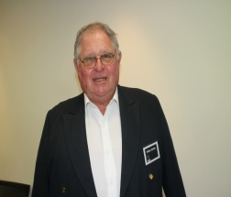Another year and another season has gone past, as we look forward to celebrating the 75th year of Softball in New Zealand, culminating with the Men’s World Championships at North Harbour in March 2013.

Over the past year we have had the New Zealand Black Sox travelling to Australia and North America, the White Sox to Australia and Canada, The Junior White Sox to South Africa for their World Championships, the U17 boys’ development team to Australia and in November the Junior Black Sox go to Argentina to compete in their World Championships.

These tours are important for the future of our game and give our young players, who benefit from our junior coaching programs, something to aspire to; in this day and age when competing with other summer sports is so important for the future of our game and keeping New Zealand as one of the most respected nations in the sport for the next 75 years.

On behalf of Softball New Zealand, I am indebted to and thank all of the management of the afore-mentioned teams for taking on the task to ensure NZ are represented at these important tournaments.

Excluding the Black Sox (who due to their success receive government funding), our other programmes have a significant portion of self-funding and without the voluntary time and effort put into fund raising by team management, the above development tours would not happen.

Hopefully with better performance at these tournaments we may qualify for more financial assistance.

I call on all members, past and present players, umpires, scorers, coaches and administrators to remember the good times you had in the game and the people you have met participating in softball in any way. The 2013 ISF World Championships at North Harbour will be the place to renew these friendships.

This event is for all New Zealand sports people, so please support it and make it a world class event that we can be proud of.

Softball needs your support more than ever next March at North Harbour to make our mark on the world scene by successfully hosting the event and regaining the title we lost to Australia in 2009.

The Black Sox have a proud tradition in this event, having won the gold medal three out of the last four World Championships, and with your help and support they will do it again.

With Softball New Zealand being in existence for the last 75 years, we have managed to build up a legacy, which is based around competing and winning World Championships and a participation base that ranks us in the top 20 in the world.

Within Softball there are also opportunities and pathways for both our male and female players which are realistic and can be extremely rewarding in terms of the experiences offered and the possibility of winning a world championship.

Further, and as has happened in the past, there are many major league scouts that already attend the international and national tournaments where a lot of our talented players are picked up.

I would like to thank all the Staff, Board members, Sponsors, umpires, scorers and once again a huge thank you to the management of our national teams who make it possible for the players to represent their country at international level.

But most of all I’d like to thank the Mums and Dads, family members and friends who give their free time to coach, umpire, score or contribute in any way to keep this wonderful sport of ours moving forward .

I would like to wish you all the best for the 2012/13 season.

My condolences go to family and friends of our members who have passed on over the last year and gone to join the team in the sky.

Last but not least, I will not be in attendance at the AGM. Please accept my apologies as I will be out of the country August /September. I would love to be there and wish you all the best for the 75th celebrations, and my heartiest congratulations one and all to the selected legions of our wonderful game.

I look forward to seeing all in March.

GO THE BLACK SOX!

## Chairman-Rex Capil



It is with pleasure that I again present the Softball NZ Chairman’s Report, this time for 2011-2012.

It has been a year of challenges and opportunities, something we would expect in the current economic climate.

The Board of Softball NZ is very much aware of the pressure faced by our Associations and clubs, and knows it is very much the members’ interests that it has to protect and represent.

Our membership is many and varied; it is preschool t-ballers, scorers at all levels, club administrators, community league participants, club ball players, employed regional managers, international players (at a junior and senior level), men, boys, women, girls, umpires at all levels, age group representative players, groundspeople, and I bet I have missed some classification out.

What this means is that with such a varied membership base, some decisions may not be what you would like or even expect. What it also means is that we all can wear many different hats, and some of us need to be conscious of what hat we may be wearing in certain instances.

What I can say unequivocally is that your Board does not prejudge situations, so is not prejudicial. Your Board does not get captured by provincial Associations or geographic representations; it represents the sport of softball for New Zealand. Your Board does expect honesty and transparency. Your Board does do its homework, gathers information and makes informed decisions. Your Board listens, hears, empathises, and understands. Your Board does ask hard questions of the staff. Your Board networks with all and sundry, from Members of Parliament to club players, from government officials to funding agency officials, with other National Sports Organisations board members, with Regional Sports Trust staff, with softballers past and present. Your Board cares about the sport of softball and the future of the game. Your Board recognises and only knows full well the meaning of this quote from Right Honourable Jim Bolger, former Prime Minister of NZ:

*“Learn from yesterday but plan for a different tomorrow. Yesterday’s thinking will not solve tomorrow’s problems.”*

It is in this context I wish to express my gratitude and thanks to the commitment shown to Softball NZ by our Board, your Board, in 2011/2012. Individually each of our Board members adds value and collectively we operate a very effective decision making and governance regime. We are prepared to debate, we are prepared to discuss, and we are prepared to listen.

Thank you to each and every one of our Board members for another year of progressing our sport, sometimes as slow and frustrating as it may seem.

We have some exciting times ahead of us. The Junior Boys World Championship in Argentina in November 2012 has been a long time coming for this team. Preparation has been extensive, workouts have been hard and we wish this team well as it heads off shore to represent Softball NZ and our country as a whole. Not only are we expecting strong performances on the diamond but we also know you will be outstanding ambassadors for our country.

We have continued to invest time and effort into our women’s programme. Therefore it was most heartening to keep track of the performance of our Junior White Sox in South Africa late in 2011. All reports back suggest this team was an outstanding success, and as a national governing body we were greatly appreciative of the hard work and results achieved. As the saying goes, hard work will always beat talent if talent doesn’t work hard.

We continue to monitor our White Sox and the international programme for our women. We understand the pressure of a self funded programme, but we also invest a huge amount of staff time in trying to minimise the overall cost per player, with significant levels of funding sourced which assists in subsidising the White Sox programme. While this does not fully fund the programme, it certainly provides a degree of financial assistance.

Another pleasing observation has been the selection of overseas based players in this team. Not only does this increase the standard but it also raises the bar for our local aspiring players to understand the necessary standard required.

Our Black Sox may seem to have remained under the radar as far as playing in NZ goes, but they have had a very successful North American tour in mid 2011 and a very successful sojourn to Australia late in 2011. All eyes will be on Rosedale Park in March 2013; our team will be ready and waiting. We must ensure we ‘get on the bus’ and support our Black Sox in their efforts to regain the World Championship title they so want. While it is as disappointing for Softball NZ as it is for the players and fans that we do not have a lot of international softball played on our shores, it means that it is all the more important that we get along, ‘get on the bus’ and support our Black Sox in March 2013, in our own backyard.

While Softball NZ does have a direct role and responsibility to ensure our international programme and teams are best prepared to perform on the international stage, we also know the significance and importance of our provincial Associations and clubs. You are the mainstay of our sport, the delivery arm for want of a better term; the ones who do the hard yards so our sport not only survives but thrives into the future. Whether you are a player, coach, scorer, umpire, administrator, supporter, or whatever, you are valuable and appreciated.

As we look forward we must determine what we want. If it is the same as we have got now, we may not have to change a lot of what we do. If it is a slight change here or there, we must be prepared to make those changes. If it is major, do we have to be like other sports and get ourselves into a crisis situation? Here’s hoping not.

What we must do is determine what it is we want and then all get in behind it to make it happen.

One thing that never ceases to amaze me is how quick we are to ‘have a crack’ against our own; abuse and accuse, fire the shots and hope they hit someone. I don’t mind being taken to task, I don’t mind being criticised, I don’t mind admitting I have made a mistake, I can even say sorry, but what I struggle with is some of the communications-verbal that I have heard and written that I have copies of, that I have seen some of our very hardworking and capable volunteers and staff have to endure. Not good, and I suppose I put the challenge out there to us, all of us, that yes we must voice our concerns or disappointments, but we must look at how we do this. In some instances it is just not acceptable what our staff have to put up with, and is not the best way to gain a collegial and collaborative alignment of what is the best for our sport. I hope people understand what it is I am saying, and if the cap fits wear it. Please modify your approach if on reflection you may think your actions in the past may not necessarily have been the best approach.

In conclusion, I wish to thank all of you again who make our sport the great sport and recreational pastime it is. The longer I am involved the more honoured I feel to be associated with Softball NZ, and I look forward to seeing us prosper in the future. A special thanks to Dane Dougan and the Softball NZ staff for their efforts again throughout 2011/12, they do an admirable job and work for the best interests of the sport and Softball NZ. We have some exciting times ahead, ‘get on the bus’ and enjoy the ride.

## General Manager-Dane Dougan

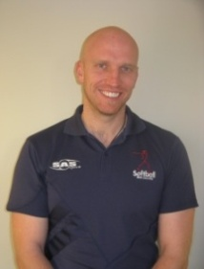

I was recently reading an article and I saw a quote that really resonated with me – “not only do most people dislike change; they don’t want things to stay the same, either. They want things to be the way they used to be.”

I have been involved in sport administration now for close to 8 years and I believe this statement is applicable and appropriate to every sport I have been involved in. It does feel that from time to time we operate in a vacuum, and forget that world outside is changing.

We do need to look back and learn from the past but we all also need to recognise that the landscape we operate in has changed significantly. To this end and with this thinking in mind I write my report for the year which is going to be focused on looking into the future of our sport.

This year gone, over and above business as usual, we have had a lot of balls in the air including the Whole of Sport Plan, Tournament reviews, Men’s World Championships on home soil and many other projects. This year will be a year where as an organisation we will be nailing these down to move forward. The bigger projects we have on the go are a new Strategic plan for the sport, finalising a game development plan for the upcoming season and beyond, and of course the ISF Men’s World Championships on the North Shore and everything that it entails.

At the time of writing SNZ had begun to formulate what the new strategic plan may look like for Softball. A full consultation process will follow this initial stage and I can assure you all this process will be all inclusive.

The finalising of a game development plan has been in the works for a while and Softball will be launching this in full for this upcoming season. This will be released prior to the season starting to allow Associations to align with the plan overall. We have trialed a number of different initiatives over the last year and those that have been seen as a success will be included in an organised and structured fashion.

And one cannot forget the opportunity that the ISF Men’s World Championships on home soil can offer. SNZ have been given a small grant from Sport NZ to work on in terms of leverage and legacy. In essence there are three key areas that we will be working on closely with Auckland and North Harbour Softball with the intent of rolling out the successful programmes in following years (this will all be included in the game development plan).

Further, SNZ are working closely with Softball 2013 to make sure that the event is a success. We thank Tony and Claire from Atlas Events for their hard work in continuing to work on making the event a success. Further and around the event SNZ will be launching the “Get on the Bus NZ Campaign” to galvanise the country behind the Black Sox. We encourage you all to get the message out and support this campaign.

At the time of writing, SNZ were finalising all World Championship Campaign preparations for the New Zealand White Sox who head for a solid build up, competing in the Canada Cup for the first time since 2006. After this, the team will then head to the ISF Women’s World Championships in Yukon Canada. No doubt, we will all be discussing their performance when we get together at the AGM.

As we have now moved into a two year World Championships it is also the turn of the Junior Black Sox to compete against the best in the world in Argentina. SNZ, as I’m sure the entire Softball community does, has high expectations for this team and are confident they will represent New Zealand with dignity and respect. On behalf of the Softball Community, I would like to wish John, Roger and the team all the best in their build up and at the World Championships.

With the above 2 year turnaround in mind we also have the Junior White Sox beginning their preparations for the next Junior World Championships this year. After an extremely successful World Championship result in late 2011, the 5th ranked team in the world will be looking to build on that experience.

And as mentioned earlier in the report, one of the biggest and most important events in SNZ’s 75 year history, the ISF Men’s World Championship, will be played on home soil. A successful Black Sox team in this event is vital for the sport in so many ways and we are working closely with the team as they build up to this event. I encourage you all to get out and support Eddie, Carl and the team on the internal tour in November this year.

To look back over the year, one of the highlights for me personally has been the relationship that SNZ has managed to build with Sky TV. For the second year in a row it has been a pleasure to work with Sky TV and I would like to thank John Fellet for his support of Softball. Wasn’t it great to see the Interislander National Fastpitch Championship televised again.

As always it is important to thank our key funders, including Sport NZ, High Performance Sport NZ and NZCT. They provide a great deal of support for our sport and it is much appreciated by all involved in Softball.

As in previous years it is vital to acknowledge and thank the Associations and all those involved in the game at the grass roots level. It is acknowledged that it is a tough environment out there and the dedication and commitment you all show to the sport is unquestionably what makes our sport tick.

It is noted that the third increase in player numbers in my time is a testament to this.

I would also like to thank and acknowledge the work that all the staff at SNZ put into the sport. This is at times a challenging job, so it is important to formally thank them all for staying positive and working towards growing our sport and making it what we all believe it should be. We have some of the most passionate softball people I have ever met, working in the SNZ office and I can guarantee you they all want to do as good a job as they can for the sport.

As with last year I would like to acknowledge the Board of Softball NZ. Their vision, support and challenging questions in governing our sport are truly appreciated.

As always I will finish off my report as I do every year, with a very special thank you for all our volunteers involved in the game. Softball would not exist as we know it now without all the people who are involved every Saturday in various ways. Your work is appreciated.

## Administration

As with previous years, Softball New Zealand (SNZ) has managed to post a modest profit this year of $34,000. This has been achieved with prudent financial management, strong relationships with our key funders and the introduction of some new partnerships.

Nothing has changed this year with our major funding partners being NZCT, Sport New Zealand and High Performance Sport New Zealand. Softball New Zealand would like to formally thank these organisations for their continued support and confidence in our organisation.

There are many other organisations that have also assisted SNZ throughout the year and their support allows us to run an efficient organisation. Among them are:

* SAS Sports
* Sirius Sport
* Bartercard
* Tandem Travel
* Interislander
* Pak n Save Petone
* Exclusive Sport

There are also various other trusts and Government agencies that support our organisation to which we are extremely thankful.

**Publicity**

As always this is an area where the SNZ office receives a lot of feedback. Hence as an organisation, we contracted Engage Group to conduct a study into communications. At the time of writing, management has been working through the recommendations from that study and is looking at all options to implement them. As always, this comes down to resources.

Again this year a very big thank you needs to go out to Sky TV, who screened the final day of the Interislander National Fastpitch Championship (NFC) live. Once again watching three live games of Softball on TV on a Sunday was received extremely well by our membership. I would like to formally acknowledge and thank John Fellet and the team at Sky TV.

Further, a big thank you to Tony Smith for his continued support of Softball throughout the year and I am sure this will continue for the 2012/2013 year.

**Interislander National Fastpitch Championship**

For the second year in a row, the NFC final day was screened live on Sky and this added to the atmosphere of the event.

With the weather playing its part this year again, the finals of the pinnacle domestic competition didn’t disappoint with the double being achieved in the championship game for the Auckland women’s and men’s teams. Congratulations to both teams in what was an impressive effort over the four days.

It is also important to acknowledge the work of Jess, Lorena and all involved in making the event a success.

Finally, I would like to thank Interislander for coming on board as naming right sponsor for the event. We are looking to build a long term and mutually beneficial relationship with them.

**National Tournaments**

One of the core areas of SNZ’s business is the running of tournaments. Being selected to represent your region in a tournament is one of the biggest honours in the sport. To all those players, coaches, managers and other team support staff I congratulate you on being part of what makes Softball great.

Further I would like to congratulate all the winners and all those players who made tournament teams. I know it is a big honour and I know how much it means to you all.

To those Associations and volunteers who ran tournaments this year on behalf of SNZ I thank you all and I have seen first-hand the amount of work that you all put into making our tournaments a success.

**National Teams**

The key event on the international Softball calendar this year was the Junior Girls World Championships in South Africa where the Junior White Sox out-did themselves and finished 5th in the World. With the start of the two year cycle of World Championship events, Venita has been reappointed as the head coach and SNZ would like to formally congratulate her and her team on the result in December 2011 and wish her all the best for the World Championships next year.

The Black Sox programme kicked into gear with a tour to North America where the team won the Legends Tournament in Kitchener Canada. This was a great effort for the team and I know Eddie and the management team managed to further refine the team and the way they would like them to play. Later in the year the team also ventured to Canberra on another successful trip. This upcoming year is one of the biggest in our sports history with Eddie, Rhys and the team on track to make it a successful year.

The New Zealand White Sox continued their build up to the 2012 World Championships with three trips to Australia to compete for the Edebone Weber Shield. I know Naomi and the coaching team learnt a lot about the players over there and at the time of writing we are all excited to follow the teams’ results at the World Championships.

The Junior Black Sox are seen as one of the favourites heading into the Junior World Championships later this year and their build up to date has been a number of camps and competing at the Southern Cross Challenge and the Poneke Kilbirnie tournament. Both tournaments were a big success, and with both the Junior White Sox and Junior Black Sox, our depth has never been better.

Finally, SNZ also sent Junior Boys and Girls Development teams to Australia with the brief of developing these players for future Sox teams. With this in mind, both these teams were a success and I would like to thank both Management teams.

## Business Development Manager-Glen Roff

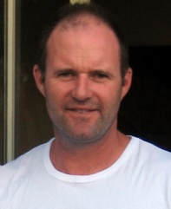As we close the 2011/2012 financial year, I would like to reflect on a number of newly formed and existing partnerships who we are immensely grateful to: Interislander – National Fastpitch Championship, Health Sponsorship Council – Community partnership/Rookie Sox, Alcohol Advisory Council of New Zealand (ALAC) – State of the game survey and community partnership, Pak n Save – National Div 1 Boys and Girls Secondary Schools, Zeald.com – Website partner and Orix and Capital City Mazda – Vehicle partners.

Softball New Zealand (SNZ) have for some time been looking to secure a vehicle sponsor with the primary purpose to increase exposure of the SNZ brand and in turn, create a greater profile for our sport. SNZ has partnered with Orix and Capital City Mazda for part sponsorship to achieve this purpose. Seven vehicles have been dispersed over the country catering for Regional Game Development Officers and SNZ Management.

Softball New Zealand has undertaken a number of pilot programme initiatives over the last 12 months in order to recruit more youth players and coaches to the game.

The Te Reo Māori/English T-Ball Passport booklet supported by Te Puni Kōkiri promoting the skills of T-Ball/Softball and revitalisation of Te Reo was successful within the Greater Wellington area. The bilingual T-Ball passport has been established to increase awareness of Te Reo Māori through the SNZ player/coach pathway, Kura Kaupapa schools and general public. The concept will now expand into further areas nationwide through the guidance of SNZ Regional Game Development Officers (RGDO’s).

Another locally implemented pilot was the Mums in Softball programme. The concept was aimed at developing and increasing numbers of female coaches in T-Ball through free T-Ball coach accreditations. The programme consisted of good participant levels, mostly new to the game of softball. Like the bilingual T-Ball passport, it too will be rolled out next season through RGDO support.

SNZ has formed a number of community partnerships in the last year supporting the awareness of health and alcohol education. SNZ is serious about improving its image and are accountable for educating and fostering healthy lifestyles within our community. Last season saw the national tournaments smokefree policy expanded to include all tournaments which was received positively by the softball community.

SNZ and the Alcohol Advisory Council of New Zealand (ALAC) have partnered to address a number of areas within our game. The main theme behind the survey revolves around the club environment, raising questions around delivery and how we cater for the community. This process has commenced through a “State of the Game” survey. The State of the Game survey will have four components to it; Club Check, Teenage female survey x 2 and a stakeholder survey. The female surveys will focus on why teenage females have left the game and the perception of softball from non-playing teenage females.

In an attempt to develop the female game, a section devoted to the female game on the SNZ website was created. The inclusion of the female development sector is based on profiling, promoting and increasing participation numbers of females in softball. The concept is aimed at assisting clubs to attract girls to play various forms of softball. The section covers various resources, links, pathways and concepts to help raise the female game and elevate it to new heights.

The Whole of Sport Plan (WoSP) has been developing quietly in the background over recent months with particular emphasis on the Life Long Player Development model, ‘heart of the WoSP’.

This season SNZ will pilot an Under 13 Rookie Sox tournament programme within the greater Wellington area. The programme is the first initiative to fall out of the WoSP.

The purpose of the Rookie Sox programme is based around the retention of players through modified softball at youth level. This programme will nurture and grow grassroots softball; particularly at the critical transitional stage of t-Ball to softball. Furthermore SNZ envisage this initiative as a catalyst for additional projects targeting all age groups and school recruitment.

The past 12 months has seen an increase in the establishment and implementation of partnership plans between RGDO’s and Associations. Over 90% of partnership plans between all Associations and RGDO’s are now complete; furthermore another 90% of expectations and outcomes from the plans have been met. In most instances outcomes achieved from partnership plans are directly related to the Sport NZ Community Sport Plan. This in itself highlights the impact of RGDO’s and Associations working together to deliver tangible outcomes. Two significant outcomes worth mentioning are; the instigation of softball programs in a variety of schools nationwide leading to 95 teams entering local competitions and secondly the securing of $48k through Kiwisport to implement school programs nationwide.

## Softball New Zealand Carded Athletes

|  |  |  |  |  |  |
| --- | --- | --- | --- | --- | --- |
| * Tyron Bartorillo | CB | * Penese Iosefo | CB | * Frank Pointon | WN |
| * Tyson Byrne | HV | * Shaun Jamieson | HV | * Jerome Raemaki | WN |
| * Thomas Cameron | WN | * Aaron Kuru | HB | * Brad Rona | NH |
| * Rhys Casley | HV | * Wayne Laulu | WN | * Pita Rona | NH |
| * Gareth Cook | CB | * Thomas Makea | WN | * Heinrick Shannon | AK |
| * Ben Enoka | AK | * Campbell Makea | WN | * Patrick Shannon | AK |
| * Karl Gollan | WN | * Jeremy Manley | HV | * Daniel Tarapi | WN |
| * Donny Hale | AK | * Jarrad Martin | WN | * Craig Wallace | WN |
| * Jerome Haretuku | AK | * Daniel Milne |  |  |  |

## Prime Minister’s Athlete Scholarships

*To be considered for a Prime Minister’s Scholarship a player needs to enrol in any tertiary or vocational qualification that is approved by the New Zealand Qualifications Authority. This includes most university and polytechnic qualifications, teaching and trade courses. The education provider must be a New Zealand organisation and the player must also meet the criteria as established by Softball New Zealand.*

|  |  |  |
| --- | --- | --- |
| ***Recipient*** | ***Association*** | ***Course of Study*** |
| Benjamin Bull | Auckland | Bachelor of Physical Education |
| Thomas Cameron | Wellington | NZ Institute of Sport Personal Training |
| Campbell Makea | Wellington | Bachelor of Physiotherapy |
| Jeremy Manley | USA | Sport and Exercise Science and a Bachelor of Science Degree |

## 2012-2013 Strategy

### PRIORITY ACTIVITY FOR 2012-2013: HIGH PERFORMANCE

* Develop a clear Talent Identification programme.
* Develop a domestic skill enhancement programme (academy).
* Develop a formal 12 month pitching and catching programme for key athletes.

### PRIORITY ACTIVITY FOR 2012-2013: LOCAL SOFTBALL DELIVERY

* Leverage the RGDO structure that will have a positive influence on relationship building with key stakeholders.
* Roll-out coaching resources specific for female players.
* Develop the slow pitch product in order to increase player numbers across the community.
* Roll-out the Rookie sox programme throughout the country.

### PRIORITY ACTIVITY FOR 2012-2013: EVENTS

* Improve the delivery of our National Tournaments in areas of:
* Supporting tournament officials;
* Tournament checklists; and
* Communication between SNZ and tournament hosts, teams and media.
* Develop an events strategy for all tournaments.
* Review and implement the 3 year NFC plan.

### PRIORITY ACTIVITY FOR 2012-2013: ORGANISATIONAL EFFECTIVENESS

* A positive change in our revenue.
* Continue with an evidence based approach to solutions (research).
* Where appropriate up skill staff and board with training and developing opportunities.

## Scorecard

|  |  |  |  |
| --- | --- | --- | --- |
| **HIGH PERFORMANCE** | | **ORGANISATIONAL EFFECTIVENESS** | |
| * To see that the recommendations from the White Sox review are implemented, particularly the Women’s Academy. | 🗶 | * To see a positive change in our Revenue. | ✓ |
| * To see that the Junior White Sox programme is delivered to ensure the best chance of success at World Championships. | ✓ | * Continue with an evidence based approach to solutions (research). | **↔** |
| * To see that the Black Sox Campaign is delivered to ensure the best chance of success. | **↔** | * Develop a system to monitor the health of Associations. | 🗶 |
| * To develop a network of Elite Pitching Coaches. | **↔** |  |  |
| **LOCAL SOFTBALL DELIVERY** | | **EVENTS** | |
| * Leverage the RGDO Structure so it will have a positive influence on relationship building with key Stakeholders. | **↔** | * Plan and Implement activity around Black Sox Events. | **↔** |
| * Develop a school softball programme. | 🗶 | * Develop an Events Strategy for Selected tournaments. | **↔** |
| * Develop Resources to support the female game. | ✓ | * Review the 3 year NFC plan. | ✓ |

* Complete
* Incomplete

**↔** Ongoing

## Honours

### International Softball Federation Hall of Fame

|  |  |  |
| --- | --- | --- |
| * Lester Baldwin 🕆 | * Lesley Monk | * Don Tricker |
| * Dennis Cheyne | * Michael Nichols | * Chubb Tangaroa |
| * Ed Dolejs | * Terry Nunns | * George Vincent QSM 🕆 |
| * Jane Earnshaw | * Charlie Phillips 🕆 | * Tom Voyle MBE 🕆 |
| * Merrell Fergusson | * Peter Priddey 🕆 | * Owen Walford |
| * Kevin Herlihy MBE 🕆 | * Paul Rogers 🕆 | * Mike Walsh |
| * Rhonda Hira | * Wayne Saunders | * Colin Ward |
| * Cheryl Kemp | * Naomi Shaw | * Marie Ward |
| * Lyndsey Leask QSM | * David Sorenson | * Ray Weaver 🕆 |
| * Marilyn Marshall | * Mark Sorenson | * Gina Weber |
| * Russell Moffatt | * Robyn Storer | * Alf Whelan MBE 🕆 |
|  |  |  |

### Softball New Zealand Hall of Fame

|  |  |  |
| --- | --- | --- |
| * Harry Atkin 🕆 | * Eddie Kohlhase | * Wayne Saunders |
| * Lester Baldwin 🕆 | * Nardi Leonard | * Naomi Shaw |
| * Wayne Baldwin | * Anne Lineham | * Dave Sorenson |
| * Don Brewer | * Dave McKerchar | * Mark Sorenson |
| * Dennis Cheyne | * Basil McLean | * Ross Smith 🕆 |
| * Jimmy Cotter 🕆 | * Bev Makinson | * Robyn Storer |
| * Ed Dolejs | * Gerry Marshall 🕆 | * Chubb Tangaroa |
| * Jane Earnshaw | * Marilyn Marshall | * Helen Townsend |
| * Merrell Ferguson | * Bill Massey | * Don Tricker |
| * Rosina Fletcher 🕆 | * Russell Moffat | * Owen Walford |
| * Jan Foote | * Lesley Monk | * Mike Walsh |
| * Esme Hamilton | * Debbie Mygind | * Colin Ward |
| * Natalie Hazelwood | * Michael Nichols | * Marie Ward |
| * Kevin Herlihy MBE 🕆 | * Terry Nunns | * Ray Weaver 🕆 |
| * Rhonda Hira | * Charlie Phillips 🕆 | * Gina Weber |
| * Kere Johanson | * Peter Priddey 🕆 | * Alf Whelan MBE 🕆 |
| * John Joyce | * Dean Rice | * Michael White |
| * Cheryl Kemp | * Paul Rogers 🕆 |  |
| * Irene Keating | * Martha Rush |  |

### Distinguished Service Awards

|  |  |  |
| --- | --- | --- |
| * Kevin Baldwin 🕆 | * L G Gibb 🕆 | * Trevor Rowse |
| * Athol Bell | * Arch Hall 🕆 | * Pene Mack |
| * Maurice Bell 🕆 | * Esme Hamilton | * Jack Mathews |
| * Valmai Breen | * Les Herbert 🕆 | * Ken Morgan |
| * Don Brewer | * Jean Humphreys 🕆 | * Jim Mulholland 🕆 |
| * Lou Brewer 🕆 | * Raewyn Humphreys | * Ellis Palmer |
| * Alf Brown 🕆 | * Doreen Hutchings 🕆 | * Joyce Phillips 🕆 |
| * Reg Cameron 🕆 | * Frank Jellyman 🕆 | * Seph Porteous |
| * Niall Campbell 🕆 | * Frank Jeromson 🕆 | * Harry Redshaw 🕆 |
| * Joyce Chapman | * Rehe Joseph 🕆 | * Jack Rochford |
| * Joe Cross | * Raewyn Judson | * Paul Rogers 🕆 |
| * Lorraine Dalley | * Don Karsten | * Stan E Smith |
| * John Eagar 🕆 | * Elaine Karsten | * W E Smith 🕆 |
| * Maurice Fenton | * H C King 🕆 | * Maureen Sorenson |
| * Ron Furlong 🕆 | * Graham Latta | * Mary Wasson 🕆 |
| * Keith Gerrie | * Thomas Laws | * Don Yeates 🕆 |
| * Eric Kohlhase 🕆 | * George McKeown 🕆 |  |

## Softball New Zealand Annual Awards 2011/2012

### Softballer of the Year 2011/2012

**John Love**

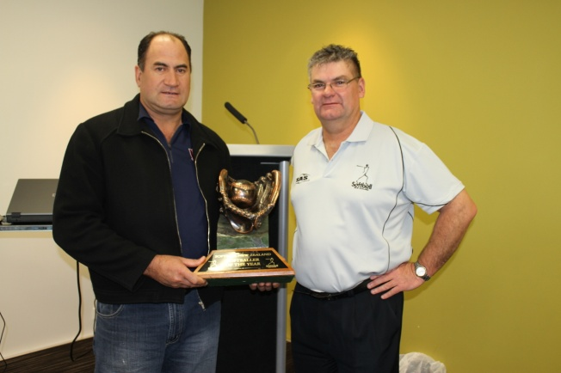John’s coaching commitment to softball can be considered immense in many areas from club level through to the Junior Black Sox.

John has displayed the same level of passion to each of the above teams that he has been involved in.

He has taken on this voluntary workload in a manner that differs from many of his club and national counterparts who are focused solely on softball during the season.

While holding a demanding investigative role within the NZ Police Force, John has been able to meet the training and playing requirements of each of the teams with the support of his team management. Needless to say the number of teams taken on is a large workload for any coach.

The closeness within the teams that he coached last season is reflected both in results and team unity on the diamond.

From a SNZ perspective, the clean sweep of Australia U19 team requires special mention, having lost to Australia at the 2008 Junior World Series. This clearly lays a positive team platform for the 2012 series in Argentina.

Following the acknowledgment of Softball New Zealand’s Coach of the Year and Softballer of the Year Awards, John was also awarded the Coach of the Year Award at the Maori Sports Awards in December 2011.

### SNZ Annual Awards

|  |  |  |
| --- | --- | --- |
| **Coach Of The Year** | John Love | Auckland |
| **Administrator Of The Year** | Guy Kawe | North Harbour |
| **Volunteer of The Year** | Ronnie Gurney | North Harbour |
| **Scorer Of The Year** | Ima Hodges | Otago |
| **Umpire Of The Year** | Lance Brown | Wanganui |
| **Personality Of The Year** | Hilton Earley | Auckland |

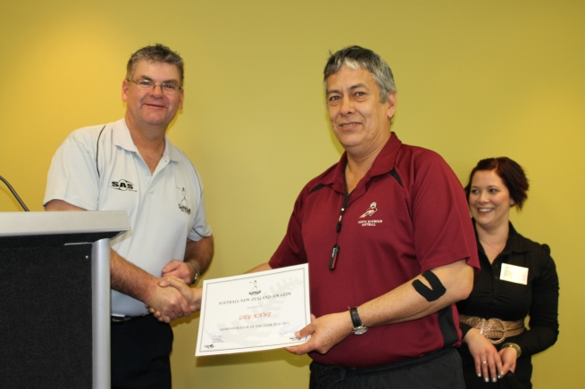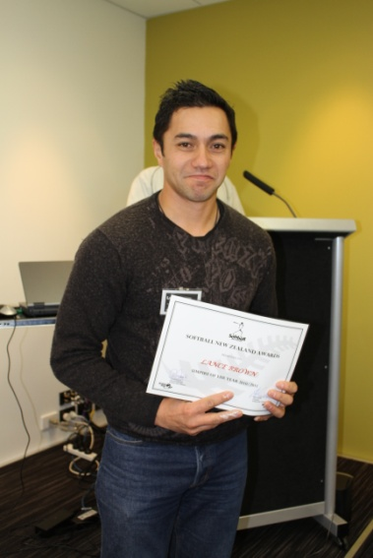

*Left:* Umpire of the Year, Lance Brown of Wanganui.

*Right:* Administrator of the Year Guy Kawe receives his Award from Head of the Honours Committee, Mike Bills.

*Below:* Volunteer of the Year Ronnie Gurney receives her award from Mike Bills.

### S:\common\Photo's Scnd Images\18 AGM\2011\IMG_1802.JPG

### SNZ Men’s Annual Awards

|  |  |  |
| --- | --- | --- |
| **Player Of The Year** | Rhys Casley | Hutt Valley |
| **Pitcher Of The Year** | Jeremy Manley | Hutt Valley |
| **Emerging Player Of The Year** | Campbell Makea | Wellington |

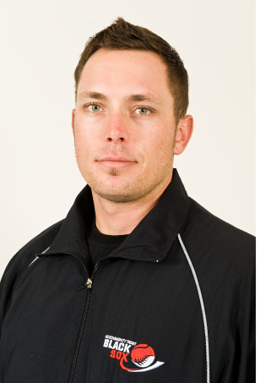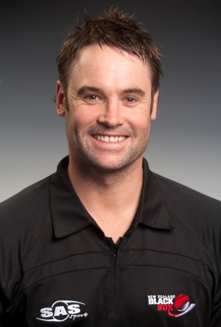

Campbell Makea

Jeremy Manley

Rhys Casley

### SNZ Women’s Annual Awards

|  |  |  |
| --- | --- | --- |
| **Player Of The Year** | Rebecca Bromhead | Auckland |
| **Pitcher Of The Year** | Megan Farrell | Auckland |
| **Emerging Player Of The Year** | Kingsley Avery | Auckland |

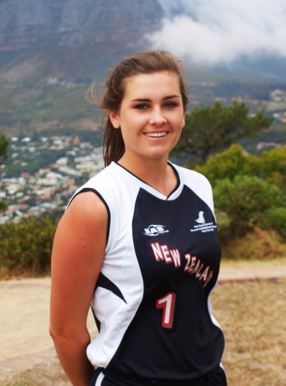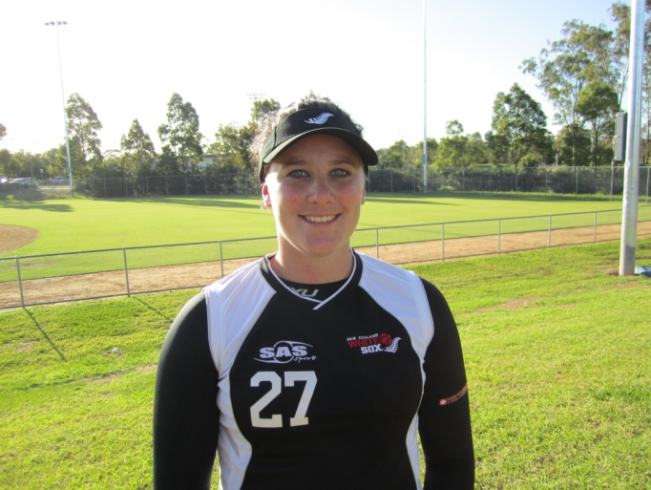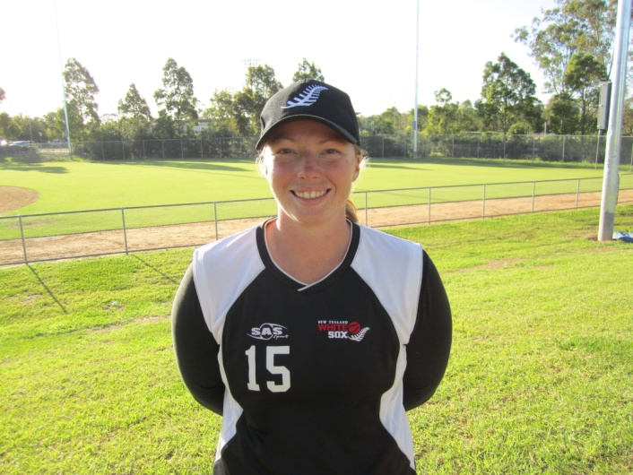

Rebecca Bromhead

Kingsley Avery

Megan Farrell

## Commercial Partners

|  |  |
| --- | --- |
| * ALAC | * New Zealand Community Trust |
| * Bartercard | * Pak n Save |
| * Exclusive Sports | * Pelorus Trust |
| * Four Winds Foundation | * SAS |
| * Health Sponsorship Council | * Sirius Sport |
| * High Performance Sport New Zealand | * Sport New Zealand |
| * Interislander | * Tandem Travel |
| * Infinity Foundation * Kingsgate Hotels | * Te Puni Kokiri * Zeald.com |





Interislander: Cook Strait Ferry Wellington & Picton, North & South Island, New Zealand

# Section Two – Reports

## High Performance Manager-Nick Cowan

The past year has proved a challenging time for the High Performance program.

The departure of Megan Harlick left high quality shoes to fill and the organisation needed to ensure its robust process continued to operate effectively to ensure the strong aspects of the programme that had been built remained. During this process High Performance functioned well and our General Manager operated the role whist conducting his own role of leading the organisation. This cannot have been easy and would have been intensely busy for Dane and I would like to thank him for keeping things moving, it certainly made for a smooth hand over.

The management team was challenged by the Board to review and look forward to how High Performance could grow to the next level and ensure success on the international stage in the men’s programme and how the organisation could better convert the high potential that a women’s programme could provide.

The later part of our financial year saw the appointment of a new High Performance Manager and with that brings fresh thinking and sometimes change. Focus was targeted toward the High Performance environment within and what value could be added to shaping the correct environment for performance.

It was also an opportunity to review how things were done and what was necessary for High Performance to grow and continue to succeed on the world stage.

The High Performance environment and the approach to the environment, talent Identification and its link to a comprehensive development programme and pitching and catching have fallen out as being important and a core focus moving forward to ensure the High Performance program remains of quality.

It is currently planned that a formal talent ID programme is developed which is linked more effectively into the needs of the SNZ senior national teams (The Black Sox and The White Sox).

A shift from tour and tournament based thinking to a more domestic skill enhancement programme (Academy) is also to be considered and work will be completed on this.

Coaching development pathways will be incorporated into this talent academy program.

The focus of the upcoming year will be to develop this and bring some of it to life.

The High Performance environment by nature can change quickly and often. Managing environments and athletes own environments within this whilst on the surface can appear simple, requires focus, time and effort. The High Performance programme will put emphasis on what an effective environment looks like and how the athlete can contribute to successful environment.

Ultimately the player determines how the environment looks and what a winning culture is.

The SNZ High Performance program will work closely with players and coaches to help shape their environment.

Finally we move into a very important phase in our High Performance development with a home World Champs for the men’s program. Much work has been done over the last four years and we are at the end point of facilitating an effective campaign for and with our Black sox regime. This will consume much of the High Performance focus.

The sport will celebrate the great opportunity to have the world of softball in our very own backyard and we look forward to a great tournament and wish our Black Sox team all the very best.

Tied in with this we have been able to confirm an internal tour for the team in November which will not only provide great build up for the Black Sox but also create an interest in this team as they go about winning back the World Championship.

I would like to thank the High Performance team both staff and volunteers for their tremendous hard work and also in assisting in the hand over to a new High Performance manager.

The sport is in great shape and its potential in High Performance remains immense.

I look forward to being part of taking softball into its next phase of High Performance growth.

## National Director of Coaching-Naomi Shaw

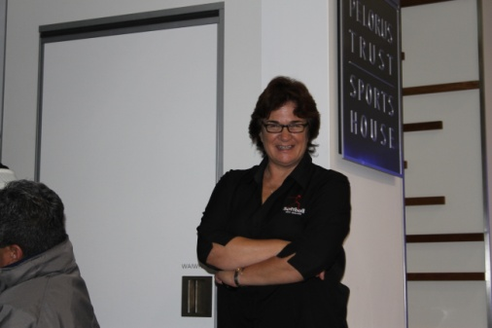

It’s another year gone by and a few more coaches are up skilled.

The Softball Coaching Strategy to maintain and enhance the coach accreditation programme continues to build and is never ending.

The modular approach to learning “Essential Skills” of Softball has gained momentum and it is pleasing to see the uptake and attendance of courses, especially from development coaches. New modules added to the development level include Pitching Mechanics & Rules; Game Strategy; Calling the Game; Fielding & Throwing & Creating Athletes Modules. Additionally the Induction Unit on Softball fundamentals is offered as a free course to primary, intermediate or secondary school teachers and we have already had a significant number of teachers undertake this coaching course.

Equally pleasing is the coaching accreditation mandate that more and more Associations are applying to applicants of their representative teams.

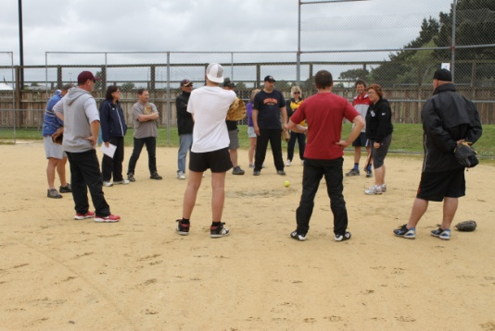Softball NZ’s Regional Game Development Officers continue to promote coaching modules within Clubs and Associations and the 1 day coaching workshop concept works well with very successful workshops held in Auckland & Southland. I took the opportunity to travel to the beautiful Deep South in November 2011 on a coaching road show and was warmly received in Alexandra, Maniototo and Invercargill. Enthusiasm &attendance was high and coaches & players were keen to learn what they could.

Regional Sports Trusts around the country continue to hold generic coach development courses that will enhance and add value to anyone attending. I attended and presented at the Greater Auckland Coaching Unit (GACU) ‘Good to Great’ Coaching Conference in Auckland in March 2012. The programme was excellent and keynote speaker Wayne Goldsmith was well worth listening to. A large number of coaches across many codes attended.

However, I was disappointed that so few softball coaches attended such an invaluable opportunity. We must never allow apathy to creep into coaching. If you are open to learning…you will always learn something from someone, somewhere.

Sport NZ continues to promote coaching as a key strategy within the Community and High Performance sectors. Their vision statement is “World Class Community Coaching at the Heart of a Sporting Nation”.

Andrew Eade is the new coaching advisor and the 2012 Sport NZ Coaching Strategy can be viewed on [www.sportnz.org.nz](http://www.sportnz.org.nz).

The fundamental beliefs that underpin the plan are:

* Coaching should focus first and foremost on the needs of the athlete being coached
* Good coaching is one of the key factors in retaining young people in sport
* Community sport is a positive force in fostering a healthy society
* Good community coaches have a positive impact on the development of young New Zealanders
* Most community sport coaches are volunteers and need to be valued as such
* There are three broad categories of community coaching – foundation, development and performance coaching – that align with the Sport NZ Athlete Development Pathway
* Coaches should be able to develop and specialize within their own coaching community
* The best learning comes through experience and continual development opportunities
* Sport owns sport – It is the responsibility of each National Sport Organisation to plan and organise the delivery of their coach development programme
* Effective delivery of coaching through community sport requires collaboration and alignment between NSO’s, Regional Sport Organisations, Regional Sport Trusts, clubs and schools
* Effective coaching at the community sport level drives sustainable growth in participation and provides a platform to develop high performance athletes and coaches

Speedy progress will happen with the collaboration and alignment of Sport NZ, Softball NZ, Associations, and Clubs & Schools. It was Selwyn Maister, former Softball CEO who quipped “we need to have everyone paddling in the same waka.”

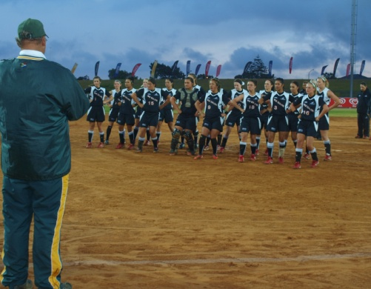The success of the Junior White Sox Team at World Series in South Africa in December 2011 was largely due to a 3 year strategic plan put in place by the team management.

The team finished in 5th place which was a huge improvement from the previous placing.

I was fortunate enough to be present in Cape Town with the supporters group.

The team played extremely well and represented themselves and NZ with passion and pride. The haka performed at the start of every match was spine tingling and stirring and set precedence for what was to follow in the game.

Congratulations are extended to team management Aroha Metcalf, Venita Hokai, Kevin Gettins, Israel Nukunuku, Keith Dare and Nicky Hansen for the fantastic work done on achieving this outstanding 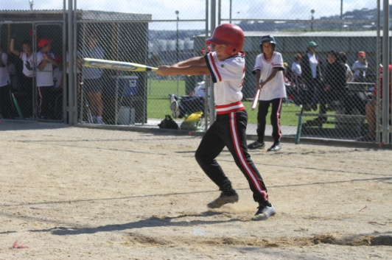result.

The NZ White Sox Selection tasted success by winning the Southern Cross Challenge Series held in Christchurch in April. Many key players were rested for this series following a busy season of domestic competition and participation in the Softball Australia National League (Gilleys Shield).

The improvement in depth of players was apparent with the team winning the final against Queensland. The win was a confidence boost as the lead in to the World Series in July commenced.

The Junior Black Sox Team also played admirably in the Southern Cross Challenge Series to finish in the final against Canterbury. The Canterbury Softball Association are to be congratulated for providing the vehicle for international competition for self funded teams, and the opportunity to showcase our national teams in New Zealand.

At the time of writing the Black Sox are on their North American tour.

Like other management teams, they are to be congratulated for their vision in developing youth alongside experience. The success of the 2013 Men’s World Series is crucial for the development of Softball in NZ.

I wish them well for their World Series preparation and look forward to watching some fantastic softball in March next year.

Plans are currently in progress to hold some coaching workshops during the Men’s World Series in North Harbour. These will be run in conjunction with the Greater Auckland Coaching Unit based at Sport North Harbour.

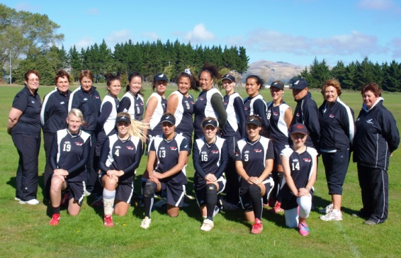The success of the NZ Development Teams programme is apparent as the depth and capability of youth players improves markedly. It is exciting times for softball as we see success at Junior Sox level and an improvement in the standard of play at age grade nationals. We must continue to foster and grow youth development and as importantly the coaches who work alongside our players of the future.

The effectiveness of Softball NZ’s Talent Identification (TID) Programme is often questioned. The bottom line for youth talent to be recognized is that players MUST attend a youth national tournament.

National Tournament Selectors attend all tournaments and from this players are named in Tournament Teams. Selectors & Coaches also have the opportunity to provide TID information on players who are NOT selected in tournament teams as players who have potential are not always named in tournament teams.  The information received is put on the TID database and is viewed and taken into consideration by coaches & selectors when they are selecting the NZ Dev Teams & Junior Sox Teams.

The current system as it sits, allows coaches (& clubs & associations) at all youth levels to provide TID information on the players they rate. Sadly...very few actually bother to complete this process and therefore disadvantage their own players by failing to do so.

The key to all of this is to provide relevant TID information by using the template provided by SNZ, make sure your talented players are attending a national tournament or at best are picked up in a regional selection team or put your hand up to be a national tournament selector!

Sincere thanks are extended to the 2011/2012 national tournament selectors Koro Amai, Robbie Cardwell, Mel England, Alex Carter, John Love, Naomi Shaw, John Lowes, Glen Metcalf, Cowley Harris, & Eugene Gilbert. I would also like to recognise the number of former & current national team players who were caught coaching youth teams this year! Fantastic stuff!

A warm welcome was extended to incoming High Performance Manager Nick Cowan in January 2012.

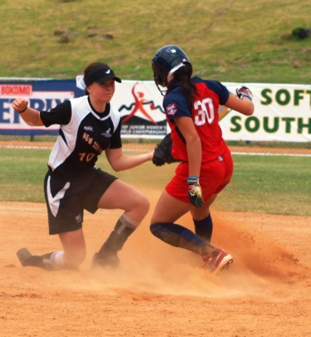Sincere thanks are extended to Softball NZ staff: Dane, Eugene, Debbie, Chris, Glen, Venita, Marnie, Cowley, Lesley, Mitch and Sophie who continue to provide ongoing support to the coaching program. I would also like to make special mention of Kath McGilbert who voluntarily maintains the TID and Coaching Databases for me.

## National Director of Pitching-Debbie Mygind

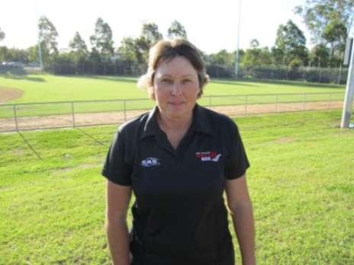Another year for the National Director of Pitching overseeing the development of pitchers and catchers.

**Coach Support Learning Opportunities**

Support to our coaches is always a priority as they are the key to player /game development. Coach learning opportunities were created as below. A fourth pitching module was added to the Essential Skills series: ES Pitching Mechanics and Rules. This module evolved from the Pitching Rules powerpoint presentation onto the diamond as a practical approach to learn leaping and to cover Rule 6 of the rule book.

In four of these modules a local umpire was also in attendance to help discuss the rules and to get the umpires perspective.

|  |  |
| --- | --- |
| Pitching Modules | Coaches accredited with course |
| U13 Rookie Sox Pitching Catching Module for beginners | 37 |
| Essential Skills Pitching Module. “The Movement Pitches” | 26 |
| Essential Skills Battery Module | 13 |
| Essential Skills Pitching Mechanics and Rules Module | 32 |

A thorough Facilitators Guidelines was completed for the existing modules ES Pitching. ‘The Movement Pitches” and the ES Battery Module as we encourage other competent coaches to present these courses locally with the RGDO administering. The ES Catching Module Facilitators Guidelines was also critiqued.

The September Regional Coaching Conference in Auckland was well attended. The 17 coaches were taken through an introduction to the new ES Pitching Mechanics & Rules Module. The conferences planned for Nelson and Waikato were mistimed and will be reconsidered for the next season.

Guest pitching/catching coaches were invited through the season to Battery clinics: Steve Jackson, Peter Mathieson, Suzy Delatour, Mel England, Ricky Early, Campbell Makea, Kiri Shaw, Melanie Gettins and Venita Hokai.

**Regional Player Clinics**

The school holidays provide a short window of opportunity to target players in the off season and pre

season. Regional Clinics were held in the July & September 2011 holidays and additional Associations were visited in November/ Dec 2011 and Feb 2012.

Player Battery Clinics were held in AK, HB, WN, HV, OT, CB, MB, NN, NO, TN where attendances totaled up to 350 players.

To coincide with the Regional and Association Clinics, pitchers and catchers were also offered a free 32 pg booklet relevant to the skills and expectation of their age group. 140 x U17 Emerging Sox Battery Guidelines Booklets were given out. This booklet offered tips on training frequency and duration, the skills required for the position and knowledge on coping with the mental side of the game.

Otago, with Jill Johnston’s creative spirit continued to invite the NDP to do monthly visits pre Xmas to assist with their academy players. A fantastic reward was the naming of Ben Watts to the NZ Junior Black Sox 2012 World Series Team to compete in Argentina.

Softball New Zealand

Pitcher Catcher Development Pathways



A long term commitment to produce top athletes in key defensive positions

**Tournaments attended**

In order to truly oversee pitchers and catchers in our game it is important to see players in games, not only in coaching clinics.

The NDP attended the following tournaments throughout the year: Lower SI U15 Boys & Girls Regional Tournament in Dunedin, Labour Weekend Waitakere Bears Tournament, U15 Girls NI Nationals in Tauranga, InterIslander National Fastpitch Championship, Bev Chote Classic, 2 days of Mens Club Nationals & 3 days of the Womens Clubs. Div 1 Secondary Schools and the Southern Cross tournament in Canterbury.

**High Performance**

The decision to continue sending a NZ Junior Development Team to attend the Youth Games in Sydney during the 2012 winter is crucial to the development of our HP game.

This tournament provides a motivational cue to players who are Talent identified and offers a clear message to ‘get busy’ now I’m in a NZ team. To help with the pitcher and catcher preparation a 28 page Battery Training Plan was sent to all players, both genders and all coaches of these teams. This booklet offered a pitcher and catcher training plan which changed weekly in the build up to the winter tournament.

The NZ White Sox Battery Camps were held in August 2011 & April 2012 where invitations went out to the wider Battery squad which also included the Junior White Sox Battery. These players were put through a series of testing and tasks.

**Challenges**:

In today’s electronic internet world there is more information available about pitching and catching for both coaches and players than ever before. The biggest challenge for the NDP is apathy and denial of knowledge.

Apathy from Coaches and Associations toward the need to have a deliberate Battery Development Plan and denial toward the leaping rules especially from older player/coaches.

The work continues into the next year to influence and effect the game for the better.

## Chief Umpire-Wayne Saunders



It is my privilege again to report on the activities of your Softball New Zealand umpiring programme. Your National Umpiring Staff continues to be a pleasure to work with, as together we balance the need to grow the **“The Programme”** while making provision for succession planning.

ISF certification is a common umpiring goal for many and this season was the start of another three year cycle that leads to the next Oceania ISF Certification Seminar which New Zealand will host in 2014. Our next group of lead-in candidates has been identified and with the assistance of the Level 7 mentoring group our final selection of candidates should be well prepared. In the last two seasons I have mentioned how well our sport has embraced the recently amended pitching regulations. The benefits of working together are best illustrated by comparing illegal pitching statistics from the 2010 Men’s Open when 131 illegal pitches were called to 2012 Men’s Open when only 30 were required to be called. Again the responsible attitude of players and coaches towards the new regulations is highly commendable.

ISF rules knowledge and mechanics are the foundations of our **“Mission Statement”** in delivering world best practice. These teachings and umpiring culture are shared through regular local and regional clinics. The Rugby World Cup played havoc with last season’s Regional Clinics; however a very successful Central Region clinic was held in Palmerston North, with a wide range of facilitators presenting. This season’s clinics will see an emphasis on the application of rules as we prepare for the new season.

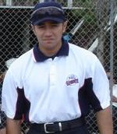At the 2011 SNZ AGM Lance Brown was named “Umpire of the Year”.

Among Lance’s appointments were: Plate Umpire to the Championship game between the Black Sox and Australia Gold in Canberra, Plate on the Final of the Men’s National Fast-pitch Championship and 1st Base on the Grand Finals of the Men’s Open and the Under 19 Boys National Tournament. Lance was also on the crew for the North Island Junior Secondary Schools Tournament. Additionally Lance serves as President of the Wanganui Softball Association.

I would like to thank the staff at SNZ and especially Eugene Gilbert for their continuing support and assistance with many logistical and planning tasks that make the show run.

**Umpire Merchandising**

We continue to thank both Ken Sommers and Jennifer Hershbein for their management of our “Schutt” umpire merchandising programme that sees New Zealand umpires amongst the best outfitted in the world. Mark McFarlane is now the NUS point of contact.

**NATIONAL UMPIRE STAFF**

AGM reports are the main source of recording umpiring history. Your NUS for last season was Wayne Saunders (UIC), Deputy Directors Cass Seeling, Daph Turner and Mark McFarlane. We were joined by Regional Directors; Dawie Sutton (Lower SI), Nicky Ogier (Upper SI), Lindsay Edwards (Central) and Bill Smith (North) along with Wiremu Tamaki (unattached). Notable among our many tasks: Nicky was Rules examiner; Wiremu Website Manager, Mark McFarlane Merchandising, Cass Seeling Clinics and Wayne National Tournament appointments. Lindsay continues as convenor of the Level 7 Advisory Group, whilst Ray Dyason, Dave Beaumont and Denis Smith joined members of the NUS as National Tournament Chief Umpires.

The National Rules refresher is held in October very year and has now been running for over twenty years. This “open book” rules test is available to anyone to sit. Increase rules knowledge benefits all.

# NATIONAL TOURNAMENTS

# This year’s national tournaments were fully staffed to meet SNZ staffing expectations.

# Thank you to Nicky Ogier for stepping at late notice to TCU the women’s open.

# National staff members were again mainly used as tournament chief umpires. This has provided better consistency with evaluating and reporting. The national tournament experience is still an ideal environment for umpires to continue to develop their knowledge and learn the culture of umpiring from their more experienced colleagues.

A total of 89 nationally graded umpires worked this year’s National Tournaments. This season we played host to Trevor Murphy and Leanne Gearside (Australia - Trans Tasman Exchange).

**INTERNATIONAL APPOINTMENTS AND INVITATIONS**

Umpires for the record following:

* 2011 ISF Junior Women’s World Series, South Africa:

Dave Shedlock

* Gilley’s Shield & Edebone-Weber Shield R1, Victoria:

Darrel Paul

* Gilley’s Shield & Edebone-Weber Shield R 2, Brisbane:

Liz Kawana

* Gilley’s Shield R3 & Edebone-Weber Shield Final Canberra:

Glen Nalepa

* ISF Oceania Men’s World Series Qualifier, Canberra:

Glen Nalepa, Mark Porteous, Wayne Saunders (UIC)

* Trans Tasman Exchange:

Gavin Shepherd,

* ISC Exchange:

Mark McFarlane,

* International Youth Series, Australia:

Judy Leaper, Andrew McManus

* ISF XIII Women’s World Series, Whitehorse, Canada:

Nicola Ogier

* Black Sox North America Tour:

Wiremu Tamaki

* ISF IX Junior Men’s World Series, Parana, Argentina:

Mark Porteous, Jeremy England

While most International field umpiring assignments have a self-funded component your umpiring programme is grateful of support from SNZ for umpires attending ISF World Championships and our established exchange programmes.

# INTERNATIONAL UMPIRING

As the ISF Regional Umpire Coordinator for Oceania it has been another active season. The ISF Congress was held in Oklahoma, USA in October 2011 and a Regional Co-ordinators meeting in Plant City, USA in June 2012. Selected points of interest from these meetings include:

* The development and issuing of the ISF Pitching Points of Emphasis and Video
* Revised three/four umpire mechanics to be uploaded to UmpSchool
* Oceania ISF certification Seminar confirmed for February 2014 in New Zealand
* Technical Bulletins will be issued by the Director of Umpire to cover interim rulings
* Rule period recertification will be effective from 1st January 2014
* All active ISF umpire are encouraged to be registered on UmpSchool ([www.ruleboxsoftware.com/isf.aspx](http://www.ruleboxsoftware.com/isf.aspx).)

**GRADING ADJUSTMENTS AND EXAMINATIONS PASSES**

As a result of National Tournament evaluations and NUS recommendations, the following grading adjustments for the 2011/2012 season are advised.

**Level 5 to Level 6** – David Beaumont (CB) and Jeff Weber (AK)

**Level 4 to Level 5** – Terry Ratu (HV) and Andrew McManus (NH).

**Level 4 Badge Examination** - the following were successful in the practical NZ Badge examination.

Tama Howard (AK), Pip Tuhoro (CB), Keith Marsh (HV), Karoline Sione (NH), Sam Meikle (OG) and Steve Sila (WN).

**Level 3 Qualifying Examination** - the following were successful in the practical NZ Qualifying examination:

Phil Easdown (CB), Mark Andrell (ML), Neil Forde (ML), Warren Herd (ML), Ben Dyason (MN), Kieran Williams (NH), Simon Lindsay (NH), Steff Chambers (NH), Tristan Hutchinson (NH), Brad Fisher (NN), Johnathon Savage (NN), Lisa Dawson (CM), Reipa Kelly (CM), Robbie Sadgrove (AK) and Cowley Harris (WK).

**Level 2 NZ Rules Examination -** the following candidates sat the NZ Rules examination and exceeded the minimum pass mark:

Robert Sadgrove (AK), Joeseph Sampson (AK), Michael Forde (AK), Tai Waru (AK), Alan Pumfleet (AK), Justin Leef (AK), Nicholas Hiku (AK), Megan Farrell (AK), Melanie Gettins (AK), Mere Stokes-McLeod (BP), Phil Easdown (CB), Lisa Dawson (CM), David Taiwhanga (CM), Jack Myers (CM), Reipa Kelly (CM), Joshua Gettins (HB), Neil Forde (ML), Mark Andrell (ML), Warren Herd (ML), Ben Dyason (MN), Mitchell Hutchinson (NH), Tristan Hutchinson (NH), Glen Schmidt (NH), Greg Donaldson (NH), Kelvin Chiles (NH), Kieran Williams (NH), Steff Chambers (NH), Tracey King (NH), Johnathon Savage (NN), Jarrod Blay (OG), Veronica Wilson (OG), Murray Rei (OG), Jeremy Rei (OG), Andre Walker (WK), Marcus Fletcher (WK) and Tarryn Fletcher (WK)

**Grading List Summary** - the overall number of graded umpires has remained relatively constant. Made up as follows: **L7** - 15 down from 16, **L6** – 11 unchanged, **L5** – 23 down from 26, **L4** – 42 down from 55, **L3** – 20 up from 11, **L2** – 30 up from 18 and **L1** - 164 up from 159. L1 umpire returns have not been received from all associations and the figure of 164 significantly under reports number of level 1 umpires active throughout New Zealand.

My personal thanks go to the National Umpiring Staff.

Deputy Director of Umpiring since 2004 Daph Turner did not stand for re-election. Daph’s many years of experience, wise counsel and tireless support for women in umpiring will be sorely missed.

Lindsay Edwards our Level 7 Group convenor and Regional Director for Central was elected as the incoming Deputy Director along with returning Deputy Director Cass Seeling.

Thank you to all who contributed to **“The Programme”.** I hope you enjoyed your umpiring experience enough to return again next season. As long as we have competitive players and coaches there will always be a need for good umpires

## Chief Scorer-Sandy Wallace

This past season has been a tough time for me personally and my family, with the sudden passing of Mum (Ima Patricia Hodges). At this time I would like to thank everyone for their support and for stepping up to the plate to cover a lot of my duties during my leave of absence, especially a huge thank you to Marie Byrne.

Mum was an important and popular member within the scorers, attending multiple tournaments each season, with her bubbly personality taking over and making each tournament more enjoyable. She had many friends, who feel bereft without her, knowing that a big hole has been left with it being impossible to fill. The scoring at tournaments will of course carry on, but for the members who knew Mum well, they will never be the same.

Mum was also our Tournaments co-ordinator making sure that each scorer had travel arranged and accommodation if required. She did this job for several years, and was well known for her efficiency. She was also known for her part in the “Back to Basics” booklet in collaboration with Pat Hannah. This booklet is still used today.

**SCORERS PANEL**

The National Scorer’s Panel over the past season was Sandy Wallace (SNZ Chief) Ronnie Gurney (SNZ Statistician) Lil Natana (Northern Region Deputy) Jo Hyde (Central Region Deputy) and Marie Byrne (Southern Region Deputy)

I wish to personally thank my panel for their commitment to our sport.

**INTERNATIONAL**

My congratulations go to the following scorers who were a part of our International teams who participated in the past twelve months:

**Keith Dare -** Junior White Sox - World Series in South Africa in December 2011.

**Vicky Griffiths -** White Sox for Edebone/Webber & Gillies Shield– December 2011.& January 2012.

**Elaine & Don Karsten –** Junior Boys and Girls

Development Teams, Friendship Series, Blacktown,

Sydney Australia in July 2011.

**Jo Hyde –** Junior Black Sox Internal Tours within New Zealand.

**2011/12 TOURNAMENTS**

Some tournaments this year were a little stretched for personnel. I thank all those that participated in Tournaments.

I would like to acknowledge the tournament Chief Scorers and Statisticians for their contribution to last season’s tournaments. I appreciate the time and effort that the following scorers put in:

**Men’s Open**

Lil Natana, Pat Hannah & Carolyn McQueen

**Women’s Open**

Sharon Williams, Vicky Griffiths

**Under 19 Boys**

Sandy Wallace, Marie Byrne

**Under 19 Girls**

Ronnie Gurney, Tracee Topia

**Under 17 Boys**

Raewyn Fergusson, Christine Nukunuku

**Under 17 Girls**

Russell Moffat, Vicky Griffiths

**Under 15 Boys N.I**.

Cat Hancock, Coralie Davies

**Under 15 Girls N.I**.

Tracee Topia, Lil Natana

**Under 15 Boys & Girls S.I**.

Ima Hodges, Ian Ditfort, Di Tulloch

**Secondary Schools**

Elaine Karsten, Lil Natana, Karen Welford

**National League**

Sandy Wallace, Elaine Karsten

**EXAMINATIONS**

The New Zealand scorers’ theory exam was held again in April, as was our refresher exam for badge-holders. Thank you again to Marie Byrne for a job well done getting these examinations out and marked.

I again wish to congratulate the following candidates below who were successful in obtaining either their NZ Badge or Qualifying examination this past season.

**NZ Badge:**

Karina Rueb (AK)

**NZ Qualifying:**

Priscilla Niuia (AK), Deborah Douglas (AK), Donna Brown(HV), Margaret Marsh(HV), Tracey Wearing (MB), Emily Wilson (WK)

**Theory Examination:**

The following people were also successful in obtaining their NZ Theory in April 2012. I welcome them to our scoring family.

Viv Washington (OT), Keriana Keen (OT), Wanita Kohu (WK), Rangiwhakaoma Te Tomo (WK)

**ACTIVE SCORERS**

**Grade 7**

Christine Nukunuku (AK), Lynnette Leathart (AK), Carolyn McQueen (NH), Ronnie Gurney (NH)  
 Lil Natana (RO),Keith Dare (HB), Cat Hancock (WG),Coralie Davies (MW),Joanne Hyde (HV),  
 Marie Byrne (CB),Pat Hannah (CB), Vicky Griffiths(CB), Russell Moffat (CB), Ian Ditfort (MB),   
Ima Hodges (OG), Sandy Wallace (OG), Elaine Karsten (SL)

**Grade 6**

Jan Hutchings (AK), Tracee Topia (AK), Helen Rogers (WK), Raewyn Fergusson (WN), Christine Eden (HV),   
Alison Kensingotn (MW), Elva Dyason (MW), Karen Welford (MW), Sharon Williams (OG), Don Karsten (SL)

**Grade 5**

Raewyn Humphreys (AK), Debbie Townley (AK), Flo Wanoa (AK), Jackie Hockley (NH), Marion Kareko (WBOP), Wendy Morris (MW), Karen Duffy (WR), Ngaire Clarke (WR), Wikitoria Morehu (HV), Jenny Allen (HV),   
Leigh Grinlinton (HV), Rose Noble (HV), Heather Graham (WN), Di Tulloch (MB), Annmarie Hoogenboozem(CB),   
Laurelle Rogers (CB), Lee-Ann Johnston (CB), Kath

McGilbert (OG)

**Grade 4**   
Deanna Callaghan (AK), Harry Wooding (AK), Nikki Woon (AK), Vanya Huntly (AK),Heidi Leathart (AK),  
Cushla Stowers (AK),Gwen Fletcher (AK), Annie Martin

(AK), Kris Jury (AK), Karina Rube (AK), Charla Edwin (NH),  
Awhina Haira (RO), Judy Beaven (HV), Lyndi Byrne (HV), Marguerite Hannah (WN), Maryanne Conroy (WN),   
Bronwyn Bleakley (WN), Danielle Fletcher (NN), Aroha

Metcalf (MB), Liz Williams (CB), Sam Tulloch (CB),  
Lynley Dove (CB), Arnya Rogers (CB), Sandra Harrison

(SL), Wendy Munro (SL), Tom McSoriley (SL),  
Susan Roy (SL)

**Grade 3**  
Priscilla Niuia (AK), Deborah Douglas (AK), Emily Wilson (WK), Margaret Marsh (HV), Donna Brown (HV), Donna Gillard (HV), Donna Handcock (WN), Tracey Wearing (MB), Cheryl Dahms (SL)

**Grade 2**  
Wanita Kohu (WK), Rangiwhakaoma Te Tomo (WK), Kay Namana (HV), Vicky O’Hagan (WN),   
Viv Washington (OT), Keriana Keen (OT)

My personal thanks go out to all of the Scorers across the country. We have a busy season ahead over the next 12 months so no doubt I will see you all around the diamonds somewhere in the near future.

# Section Three – The Game

## National Team Results

|  |  |  |  |  |  |  |  |  |  |  |  |
| --- | --- | --- | --- | --- | --- | --- | --- | --- | --- | --- | --- |
| **C:\Users\srobbers\AppData\Local\Microsoft\Windows\Temporary Internet Files\Content.Outlook\ZAIGF2S3\bsoxlogo.jpgC:\Users\srobbers\Downloads\ACT.jpgNew Zealand Black Sox**  **Skins Tournament**  **Hawker International Softball Centre**  **ACT, Australia**  **Friday 2nd to Sunday 4th December 2011**  *The Black Sox headed to Canberra to compete in the high intensity Skins tournament against the best teams that Australia has to offer. They were successful winning every game that they played but were unable to claim the win due to being an International side.* | | | | | | | | | | | |
| * Tyrone Barterillo | | | CB | * Shaun Jamieson | | | HV | * Aaron Neemia | | | WN |
| * Tyson Byrne | | | HV | * Wayne Laulu | | | WN | * Frank Pointon | | | WN |
| * Thomas Cameron | | | WN | * Campbell Makea | | | WN | * Jerome Raemaki | | | WN |
| * Rhys Casley | | | HV | * Thomas Makea | | | WN | * Pita Rona | | | NH |
| * Casey Eden | | | AK | * Jeremy Manley | | | USA | * Dan Tarapi | | | WN |
| * Ben Enoka | | | AK | * Regan Manley | | | HB | * Nathan Taikato | | | CB |
| * Jerome Haretuku | | | AK | * Jarrod Martin | | | WN |  | | |  |
| * Penese Iosefo | | | CB | * Daniel Milne | | | CB |  | | |  |
| Black Sox Management Team | | | | | | | | | | | |
| **Head Coach** | Eddie Kohlhase | | | | | **Manager** | | | Jayden Moore | | |
| **Assistant Coach** | Dave Workman | | | | | **Physiotherapist** | | | Rob Cashman | | |
| **Pitching Coach** | Chubb Tangaroa | | | | |  | | |  | | |
| Tournament Results | | | | | | | | | | | |
| Opposition | | Result | | | Runs For | | | | | Runs Against | |
| Sharks | | Win | | | 4 | | | | | 3 | |
| Upstarts | | Win | | | 9 | | | | | 6 | |
| Eastern Bucks | | Win | | | 7 | | | | | 4 | |
| Mounties | | Win | | | 5 | | | | | 2 | |
| Monarchs | | Win | | | 9 | | | | | 4 | |
| Raptors | | Win | | | 10 | | | | | 0 | |
| Strike Zone | | Win | | | 5 | | | | | 0 | |

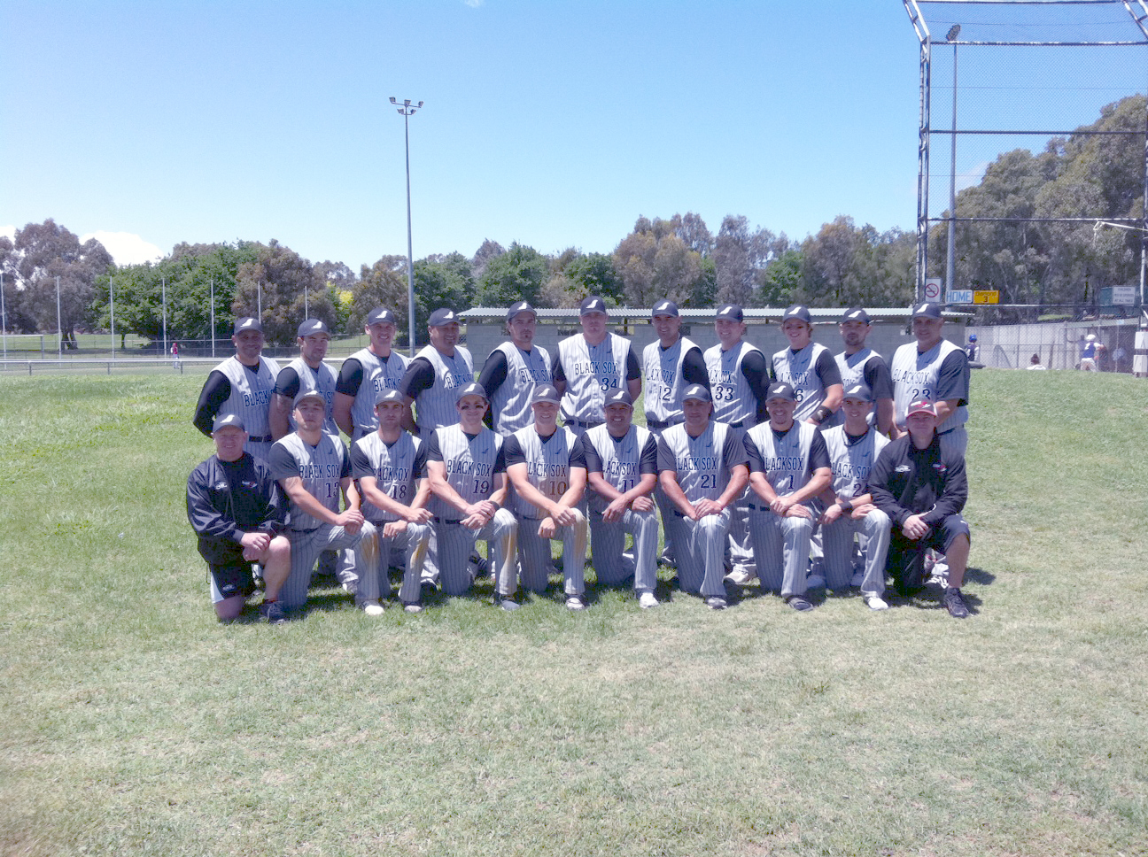

|  |  |  |  |  |  |  |  |  |  |  |  |  |  |  |
| --- | --- | --- | --- | --- | --- | --- | --- | --- | --- | --- | --- | --- | --- | --- |
| **http://www.kwfastball.com/images/Legends%20Logo.jpg**  **C:\Users\srobbers\AppData\Local\Microsoft\Windows\Temporary Internet Files\Content.Outlook\ZAIGF2S3\bsoxlogo.jpgNew Zealand Black Sox**  **North America Tour**  **Legends of Fastball Classic**  **Kitchener, Canada**  **June 18th to June 28th 2011** | | | | | | | | | | | | | | |
| *The Black Sox embarked for a 20-day tour which saw the side play a number of games including the Legends of Fastball Classic tournament in Kitchener, Canada and the Peligro tournament in New York, USA.* | | | | | | | | | | | | | | |
| * Tyron Baterillo | | | | CB | * Karl Gollan | | | | USA | * Jeremy Manley | | | | USA |
| * Tyson Byrne | | | | HV | * Jerome Haretuku | | | | AK | * Daniel Milne | | | | CB |
| * Thomas Cameron | | | | WN | * Penese Iosefo | | | | CB | * Jerome Raemaki | | | | WN |
| * Rhys Casley | | | | HV | * Wayne Laulu | | | | WN | * Pita Rona | | | | NH |
| * Casey Eden | | | | AK | * Campbell Makea | | | | WN | * Nathan Taikato | | | | CB |
| * Ben Enoka | | | | AK | * Thomas Makea | | | | WN | * Daniel Tarapi | | | | WN |
| Black Sox Management Team | | | | | | | | | | | | | | |
| **Head Coach** | Eddie Kohlhase | | | | | | | **Manager** | | | Doug Golightly | | | |
| **Assistant Coach** | Dave Workman | | | | | | | **Technical Analyst** | | | Craig Soper | | | |
| **Pitching Coach** | Chubb Tangaroa | | | | | | | **Physiotherapist** | | | Rob Cashman | | | |
| **Legends of Fastball Classic** | | | | | | | | | | | | | | |
| Opposition | | | Result | | | | Runs For | | | | | Runs Against | | |
| League All Star Team | | | Win | | | | 15 | | | | | 1 | | |
| League All Star Team | | | Win | | | | 3 | | | | | 0 | | |
| Kitchener Cubs | | | Loss | | | | 0 | | | | | 5 | | |
| Tri-Country All Star Team | | | Win | | | | 3 | | | | | 0 | | |
| Owen Sound Selects | | | Win | | | | 5 | | | | | 1 | | |
| Elmira Expos | | | Win | | | | 8 | | | | | 1 | | |
| Port Elgin Blue Devils | | | Win | | | | 7 | | | | | 0 | | |
| Chicago-New York | | | Win | | | | 4 | | | | | 1 | | |
| Midland Explorers | | | Win | | | | 5 | | | | | 4 | | |
| **Final** | | | | | | | | | | | | | | |
| Jarvis | | Win | | | | 4 | | | | | | | 3 | |
| **Other Games** | | | | | | | | | | | | | | |
| Jarvis | | Loss | | | | 6 | | | | | | | 12 | |
| Jarvis | | Win | | | | 4 | | | | | | | 3 | |

|  |  |  |  |  |  |  |  |  |  |  |  |  |  |  |
| --- | --- | --- | --- | --- | --- | --- | --- | --- | --- | --- | --- | --- | --- | --- |
| **http://www.fastpitchwest.com/wp-content/uploads/2010/12/peligro.png**  **C:\Users\srobbers\AppData\Local\Microsoft\Windows\Temporary Internet Files\Content.Outlook\ZAIGF2S3\bsoxlogo.jpgNew Zealand Black Sox**  **North America Tour**  **Peligro Tournament**  **New York, USA**  **June 28th to July 9th 2011** | | | | | | | | | | | | | | |
| * Ben Bull | | | | AK | * Karl Gollan | | | | USA | * Thomas Makea | | | | WN |
| * Tyson Byrne | | | | HV | * Jerome Haretuku | | | | AK | * Jeremy Manley | | | | USA |
| * Thomas Cameron | | | | WN | * Aaron Kuru | | | | HB | * Brad Rona | | | | NH |
| * Rhys Casley | | | | HV | * Wayne Laulu | | | | WN | * Patrick Shannon | | | | AK |
| * Ben Enoka | | | | AK | * Campbell Makea | | | | WN | * Daniel Tarapi | | | | WN |
| Black Sox Management Team | | | | | | | | | | | | | | |
| **Head Coach** | Eddie Kohlhase | | | | | | | **Manager** | | | Doug Golightly | | | |
| **Assistant Coach** | Dave Workman | | | | | | | **Video Technician** | | | Craig Soper | | | |
| **Pitching Coach** | Chubb Tangaroa | | | | | | | **Physiotherapist** | | | Rob Cashman | | | |
| **Peligro Tournament** | | | | | | | | | | | | | | |
| Opposition | | | Result | | | | Runs For | | | | | Runs Against | | |
| California | | | Win | | | | 3 | | | | | 0 | | |
| Industriales | | | Win | | | | 3 | | | | | 2 | | |
| NY Sports Bar | | | Loss | | | | 3 | | | | | 4 | | |
| Domincana | | | Loss | | | | 0 | | | | | 3 | | |
| **Playoffs** | | | | | | | | | | | | | | |
| Chicago-New York | | Win | | | | 3 | | | | | | | 2 | |
| **Semi Final** | | | | | | | | | | | | | | |
| California | | Loss | | | | 0 | | | | | | | 2 | |
|  | |  | | | |  | | | | | | |  | |

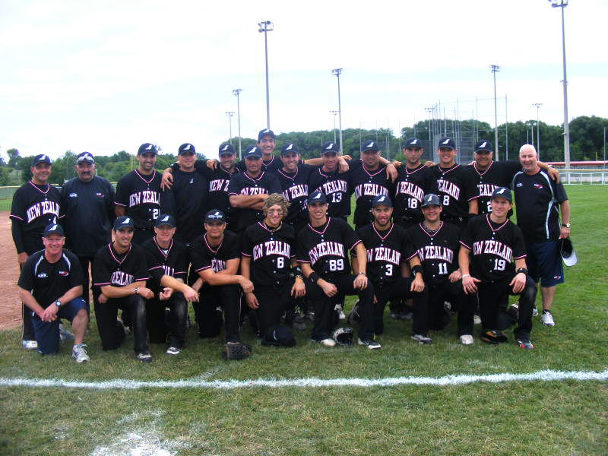

|  |  |  |  |  |  |  |  |  |  |  |  |
| --- | --- | --- | --- | --- | --- | --- | --- | --- | --- | --- | --- |
| **C:\Users\srobbers\AppData\Local\Microsoft\Windows\Temporary Internet Files\Content.Outlook\ZAIGF2S3\New Image.JPGC:\Users\srobbers\Downloads\VIC.jpgNew Zealand White Sox**  **Edebone-Weber Shield**  **Weekend 1-Waverley, Victoria, Australia**  **28th to 30th October 2011** | | | | | | | | | | | |
| *The New Zealand White Sox played in the Edebone-Weber Shield in Australia over three weekends from October 2011 to January 2012. The Squad for the first two weekends was the same and changed slightly for weekend 3.* | | | | | | | | | | | |
| * Tianna Areaiiti | | | SL | * Danica Ferriso | | | HV | * Charlotte Pointon | | | WN |
| * Kyla Bromhead | | | AK | * Alex Forsyth | | | AUS | * Aperira Stone | | | AUS |
| * Rebecca Bromhead | | | AK | * Melanie Gettins | | | AK | * Michal Tangaroa | | | AK |
| * Poihaere Clark | | | AUST | * Katarina Hiku | | | AK | * Courtney Warren | | | AK |
| * Brooke Cutting | | | WN | * Ngamoko Hiku | | | AUST |  | | |  |
| * Megan Farrell | | | AK | * Amanda Preston | | | AK |  | | |  |
| White Sox Management Team | | | | | | | | | | | |
| **Head Coach** | Naomi Shaw | | | | | **Scorer** | | | Vicky Griffiths | | |
| **Assistant Coach** | Debbie Mygind/Israel Nukunuku | | | | | **Physiotherapist** | | | Kirsty Currie | | |
| **Manager** | Anaru Pewhairangi | | | | |  | | |  | | |
| Series Results | | | | | | | | | | | |
| Opposition | | Result | | | Runs For | | | | | Runs Against | |
| ACT Diamonds | | Win | | | 4 | | | | | 3 | |
| SA Starz | | Loss | | | 0 | | | | | 1 | |
| Vic Titans | | Loss | | | 1 | | | | | 2 | |
| Queensland Heat | | Loss | | | 1 | | | | | 7 | |
| WA Flames | | Loss | | | 2 | | | | | 9 | |



|  |  |  |  |
| --- | --- | --- | --- |
| **C:\Users\srobbers\AppData\Local\Microsoft\Windows\Temporary Internet Files\Content.Outlook\ZAIGF2S3\New Image.JPGNew Zealand White Sox**  **Edebone-Weber Shield**  **Weekend 2-Downey Park, Queensland, Australia**  **24th to 27th November 2011** | | | |
| Series Results | | | |
| Opposition | Result | Runs For | Runs Against |
| Vic Titans | Loss | 1 | 7 |
| WA Flames | Loss | 1 | 12 |
| NSW Firestars | Loss | 9 | 2 |
| SA Starz | Loss | 4 | 1 |

|  |  |  |  |  |  |  |  |  |  |  |  |  |
| --- | --- | --- | --- | --- | --- | --- | --- | --- | --- | --- | --- | --- |
| **C:\Users\srobbers\AppData\Local\Microsoft\Windows\Temporary Internet Files\Content.Outlook\ZAIGF2S3\New Image.JPGC:\Users\srobbers\Downloads\ACT.jpgNew Zealand White Sox**  **Edebone-Weber Shield**  **Weekend 3-Hawker, ACT, Australia**  **04th to 7th January 2012** | | | | | | | | | | | | |
| * Kyla Bromhead | | | AK | * Melanie Gettins | | | AK | * Charlotte Pointon | | | | WN |
| * Rebecca Bromhead | | | AK | * Robyn Hall | | | CB | * Kiri Shaw | | | | HV |
| * Sheree Cartwright | | | WN | * Ashley Johnston | | | HV | * Katrina Stockford | | | | AK |
| * Poihaere Clark | | | AUST | * Te-Reo-Powhiri Matautia | | | AK | * Michal Tangaroa | | | | AK |
| * Megan Farrell | | | AK | * Brooke McManus | | | AUST | * Megan Tasker | | | | WN |
| White Sox Management Team | | | | | | | | | | | | |
| **Head Coach** | Naomi Shaw | | | | | **Manager** | | | Anaru Pewhairangi | | | |
| **Assistant Coach** | Debbie Mygind/Israel Nukunuku | | | | | **Scorer** | | | Vicky Griffiths | | | |
| Series Results | | | | | | | | | | | | |
| Opposition | | Result | | | Runs For | | | | | Runs Against | | |
| SA Starz | | Loss | | | 0 | | | | | 7 | | |
| WA Flames | | Loss | | | 5 | | | | | 9 | | |
| NSW Firestars | | Loss | | | 0 | | | | | 9 | | |
| ACT Diamonds | | Loss | | | 4 | | | | | 6 | | |
| Queensland Heat | | Loss | | | 3 | | | | | 4 | | |
| Vic Titans | | Loss | | | 0 | | | | | 4 | | |
| SA Starz | | Loss | | | 0 | | | | | 3 | | |
| Vic Titans | | Loss | | | 0 | | | | | 9 | | |
| **C:\Users\srobbers\AppData\Local\Microsoft\Windows\Temporary Internet Files\Content.Outlook\ZAIGF2S3\New Image.JPGOpen Women’s Test Series**  **New Zealand White Sox Vs. Australia**  **Hawker International Softball Centre**  **Canberra**  **07th-08th January 2012** | | | | | | | | | | | | |
| *Following the final weekend of the Edebone-Weber Shield, the NZ White Sox competed in a 3 game test series against Australia. The team remained the same as the final Edebone-Weber games with the inclusion of Jessica Hollett.* | | | | | | | | | | | | |
| Test Result | | | | | | | | | | | | |
| Opposition | | Result | | | Runs For | | | | | | Runs Against | |
| Australia | | Loss | | | 1 | | | | | | 9 | |
| Australia | | Loss | | | 4 | | | | | | 11 | |
| Australia | | Loss | | | 0 | | | | | | 8 | |

|  |  |  |  |  |  |  |  |  |  |  |  |
| --- | --- | --- | --- | --- | --- | --- | --- | --- | --- | --- | --- |
| **C:\Users\srobbers\AppData\Local\Microsoft\Windows\Temporary Internet Files\Content.Outlook\ZAIGF2S3\New Image.JPGNew Zealand White Sox**  **Southern Cross Challenge**  **Mainland Foundation Ballpark, Canterbury**  **5th to 9th April 2012** | | | | | | | | | | | |
| *Looking towards 2014, the White Sox Selectors named a team to compete in the Southern Cross Challenge Series in Christchurch in April. The series was held over Easter Weekend and is competed between Queensland and Canterbury Teams.* | | | | | | | | | | | |
| * Tianna Areaiiti | | | SL | * Brooke McManus | | | AUS | * Tailotu Tonu’u | | | WN |
| * Kyla Bromhead | | | AK | * Beth Stavert | | | AK | * Gillian Wells | | | AK |
| * Melanie Gettins | | | AK | * Michal Tangaroa | | | AK |  | | |  |
| * Krysta Hoani | | | AK | * Danielle Tanoa | | | WN |  | | |  |
| White Sox Management Team | | | | | | | | | | | |
| **Head Coach** | Naomi Shaw | | | | | **Scorer** | | | Vicky Griffiths | | |
| **Assistant Coach** | Debbie Mygind/Israel Nukunuku | | | | | **Physiotherapist** | | | Nicky Hansen | | |
| **Manager** | Lyn Lockhart | | | | |  | | |  | | |
| Series Results | | | | | | | | | | | |
| Opposition | | Result | | | Runs For | | | | | Runs Against | |
| Canterbury Development | | Win | | | 7 | | | | | 0 | |
| Queensland Maroon | | Win | | | 7 | | | | | 0 | |
| Canterbury Red Hawks | | Loss | | | 0 | | | | | 1 | |
| Queensland Heat | | Loss | | | 0 | | | | | 3 | |
| Canterbury Red Hawks | | Win | | | 3 | | | | | 2 | |
| Queensland Heat | | Loss | | | 4 | | | | | 8 | |
| Canterbury Red Hawks | | Win | | | 8 | | | | | 4 | |

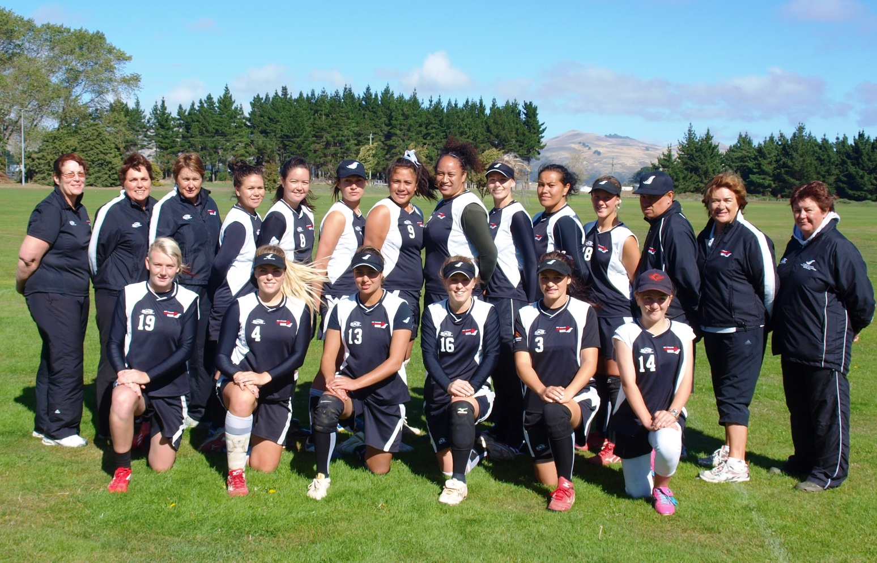

|  |  |  |  |  |  |  |  |  |  |  |  |
| --- | --- | --- | --- | --- | --- | --- | --- | --- | --- | --- | --- |
| **S:\common\Photo's Scnd Images\15 Logo's\Fern\Black_Sox_Fern.jpgJunior Black Sox**  **Eagles Softball Labour Weekend Open 2011**  **Saxton Park, Nelson**  **29th to 31st October 2011**  **Junior Black Sox** | | | | | | | | | | | |
| *The Junior Black Sox headed to Nelson to compete in the Eagles Softball Labour Weekend Open 2011 as the beginning of their preparations for the World Championships in Parana, Argentina November 2012.* | | | | | | | | | | | |
| * Edward Albright | | | HV | * Tamihana Nau | | | NH | * Kurt Schollum | | | MB |
| * Ben Bull | | | AK | * Campbell Ngarimu | | | HV | * Zane Siolo | | | HV |
| * Morgan Timoti-Cook | | | NH | * Matthew Oxley | | | AK | * Andrew Verhuel | | | CB |
| * Campbell Enoka | | | AK | * Joshua Pettett | | | NH | * Matt Verhuel | | | CB |
| * Campbell Gaunt | | | HV | * Jerome Raemaki | | | WN |  | | |  |
| * Hohepa Monk | | | WK | * Pita Rona | | | NH |  | | |  |
| Junior Black Sox Management Team | | | | | | | | | | | |
| **Head Coach** | John Love | | | | | **Manager** | | | Softball NZ Representative | | |
| **Assistant Coach** | Phil Johnston | | | | | **Scorer** | | | Joanne Hyde | | |
| Series Results | | | | | | | | | | | |
| Opposition | | Result | | | Runs For | | | | | Runs Against | |
| Poneke Kilbirnie | | Loss | | | 2 | | | | | 10 | |
| Hutt Valley Marist | | Loss | | | 4 | | | | | 5 | |
| Auckland United | | Loss | | | 4 | | | | | 12 | |
| Porirua City United | | Loss | | | 3 | | | | | 4 | |
| C:\Users\srobbers\AppData\Local\Microsoft\Windows\Temporary Internet Files\Content.Outlook\ZAIGF2S3\IMG_0152.JPG | |  | | |  | | | | |  | |
|  | |  | | |  | | | | |  | |

|  |  |  |  |  |  |  |  |  |  |  |  |
| --- | --- | --- | --- | --- | --- | --- | --- | --- | --- | --- | --- |
| **S:\common\Photo's Scnd Images\15 Logo's\Fern\Black_Sox_Fern.jpghttp://www.sportsground.co.nz/files/site/625/0/111208231223MGHPDAWK.jpgJunior Black Sox**  **PK Classic**  **Hataitai Park, Wellington**  **20th to 23rd January 2012**  **Junior Black Sox** | | | | | | | | | | | |
| *Following on from the National U19s the following players were selected to play in the PK tournament over Wellington anniversary weekend, starting Friday night against the host Poneke Kilbirnie.* | | | | | | | | | | | |
| * Edward Albright | | | HV | * Campbell Gaunt | | | HV | * Zane Siolo | | | HV |
| * Karaitiana Aranui | | | HB | * Max Hodgekinson | | | NH | * Matt Verhuel | | | CB |
| * Danny Brown | | | WN | * Tailah Love | | | WN | * Ben Watts | | | OT |
| * Tim Campbell | | | SL | * Campbell Ngarimu | | | HV | * Cory Wilson | | | NH |
| * Josh Dickson | | | CB | * Regan O’Neill | | | AK |  | | |  |
| * Joe Ferriso | | | HV | * Jackson Prime | | | NH |  | | |  |
| Junior Black Sox Management Team | | | | | | | | | | | |
| **Head Coach** | John Love | | | | | **Manager** | | | Roger Aranui | | |
| **Assistant Coach** | Phil Johnston | | | | | **Scorer** | | | Joanne Hyde | | |
| Series Results | | | | | | | | | | | |
| Opposition | | Result | | | Runs For | | | | | Runs Against | |
| Poneke Kilbirnie | | Loss | | | 2 | | | | | 10 | |
| Hutt Valley Marist | | Loss | | | 4 | | | | | 5 | |
| Auckland United | | Loss | | | 4 | | | | | 12 | |
| Porirua City United | | Loss | | | 3 | | | | | 4 | |
|  | |  | | |  | | | | |  | |
|  | |  | | |  | | | | |  | |

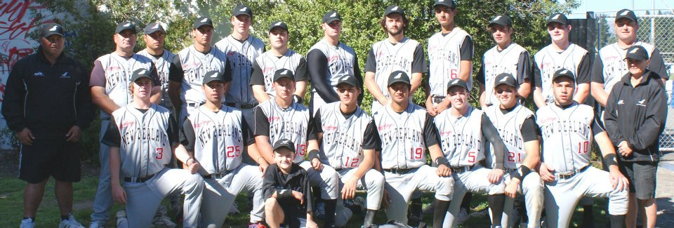

|  |  |  |  |  |  |  |  |  |  |  |  |
| --- | --- | --- | --- | --- | --- | --- | --- | --- | --- | --- | --- |
| **S:\common\Photo's Scnd Images\15 Logo's\Fern\Black_Sox_Fern.jpgJunior Black Sox**  **Southern Cross Challenge**  **Mainland Foundation Ballpark-Canterbury**  **Junior Black Sox 5th to 9th April 2012** | | | | | | | | | | | |
| *The Junior Black Sox competed in the Southern Cross Challenge in Christchurch in April. The series was held over Easter Weekend and is competed between Queensland and Canterbury Teams.* | | | | | | | | | | | |
| * Edward Albright | | | HV | * Tamihana Nau | | | NH | * Jerome Raemaki | | | WN |
| * Ben Bull | | | AK | * Campbell Ngarimu | | | HV | * Pita Rona | | | NH |
| * Tim Campbell | | | SL | * Regan O’Neil | | | AK | * Ben Watts | | | OT |
| * Morgan Timoti-Cook | | | NH | * Matthew Oxley | | | AK | * Corey Wilson | | | NH |
| * Campbell Enoka | | | AK | * Josh Pettett | | | NH | * Bradley Worsley | | | HV |
| * Hohepa Monk | | | WK | * Jackson Prime | | | NH |  | | |  |
| Junior Black Sox Management Team | | | | | | | | | | | |
| **Head Coach** | John Love | | | | | **Manager** | | | Roger Aranui | | |
| **Assistant Coach** | Phil Johnston | | | | | **Scorer** | | | Joanne Hyde | | |
| Series Results | | | | | | | | | | | |
| Opposition | | Result | | | Runs For | | | | | Runs Against | |
| Canterbury Red Sox | | Loss | | | 0 | | | | | 8 | |
| United All Stars | | Win | | | 4 | | | | | 2 | |
| Queensland | | Loss | | | 2 | | | | | 3 | |
| Canterbury Development | | Win | | | 8 | | | | | 0 | |
| Queensland | | Loss | | | 2 | | | | | 3 | |
| Canterbury Red Sox | | Loss | | | 2 | | | | | 4 | |
| Queensland Heat | | Loss | | | 4 | | | | | 8 | |
| Canterbury Red Sox | | Loss | | | 2 | | | | | 6 | |

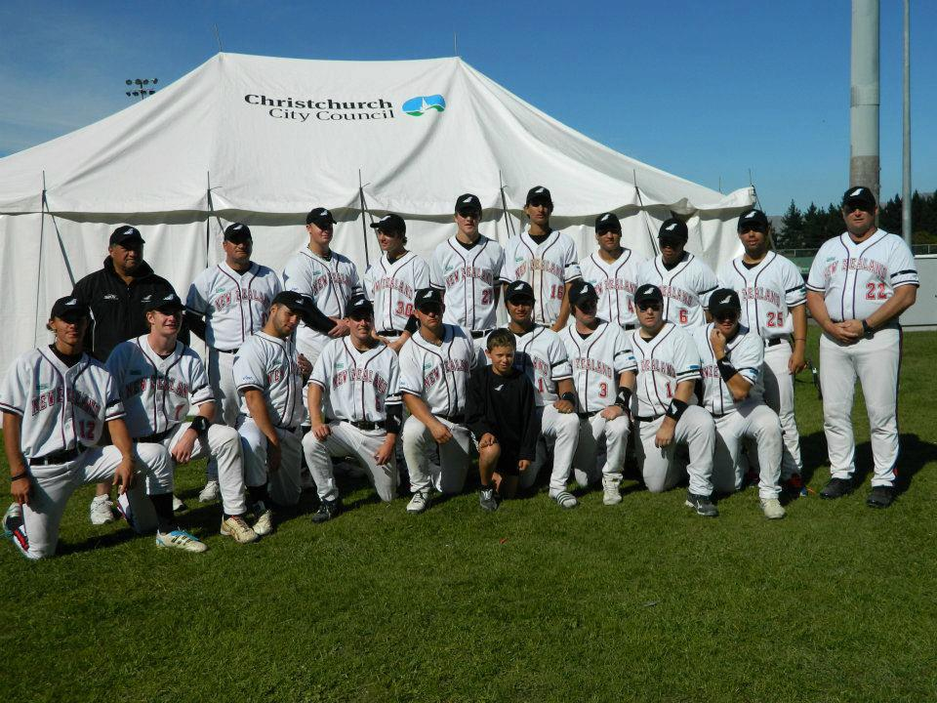

|  |  |  |  |  |  |  |  |  |  |  |  |
| --- | --- | --- | --- | --- | --- | --- | --- | --- | --- | --- | --- |
| **cid:image001.jpg@01CD3D87.0C6BC0C0S:\common\Photo's Scnd Images\15 Logo's\Fern\Black_Sox_Fern.jpgJunior White Sox**  **Waitakere Bears Tournament**  **Starling Park, Auckland**  **Junior White Sox 22nd to 24th October 2011** | | | | | | | | | | | |
| *The Junior White Sox competed in the Waitakere Bears Classic Tournament held in Auckland, in the lead up to the Junior Women’s World Champs in Cape Town, South Africa.* | | | | | | | | | | | |
| * Danica Ferriso | | | HV | * Jordan-Leigh Koni | | | AK | * Taylor-Paige Stewart | | | USA |
| * Alex Forsyth | | | AUST | * Anita Leeuw | | | SL | * Lauren Sutherland | | | CB |
| * Robyn Hall | | | CB | * Katie McAndrew | | | WN | * Danielle Tanoa | | | WN |
| * Santana Harris | | | AK | * Jordan Mumu | | | HV | * Chance Warbrick | | | HV |
| * Krysta Hoani | | | AK | * Kuraroa Ratu-James | | | HV |  | | |  |
| Junior White Sox Management Team | | | | | | | | | | | |
| **Head Coach** | Venita Hokai | | | | | **Manager** | | | Aroha Metcalf | | |
| **Assistant Coach** | Kevin Gettins/Israel Nukunuku | | | | | **Scorer** | | | Keith Dare | | |
| Series Results | | | | | | | | | | | |
| Opposition | | Result | | | Runs For | | | | | Runs Against | |
| Waitakere Bears | | Win | | | 3 | | | | | 2 | |
| Ramblers | | Win | | | 1 | | | | | 0 | |
| Papatoetoe | | Loss | | | 0 | | | | | 7 | |
| Waitakere Bears | | Loss | | | 0 | | | | | 3 | |
| Ramblers | | Loss | | | 3 | | | | | 5 | |
| Papatoetoe | | Loss | | | 0 | | | | | 3 | |
|  | | **FINAL** | | | | | | | |  | |
| Ramblers | | Win | | | 8 | | | | | 1 | |

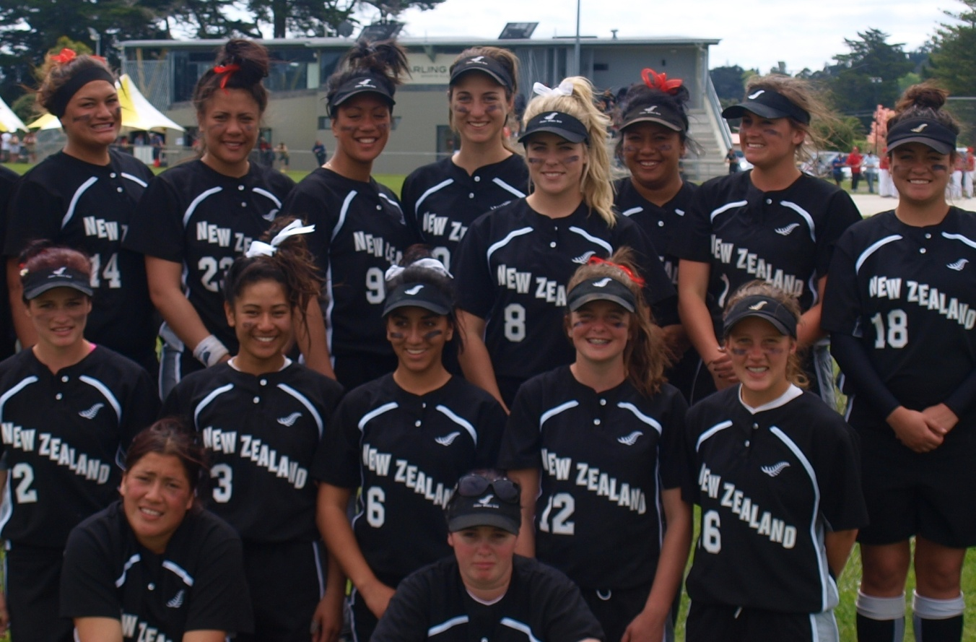

|  |  |  |  |  |  |  |  |  |  |  |  |
| --- | --- | --- | --- | --- | --- | --- | --- | --- | --- | --- | --- |
| **jnr-logo.gifS:\common\Photo's Scnd Images\15 Logo's\Fern\Black_Sox_Fern.jpgJunior White Sox**  **IX ISF Junior Women’s World Championships**  **Turfhall Softball Stadium, Cape Town, South Africa**  **6th to 17th December 2011** | | | | | | | | | | | |
| *The Junior White Sox headed to Cape Town, South Africa in December of 2011 to compete in the IX ISF Junior Women’s World Championships. The team played extremely well and finished the competition 5th equal.* | | | | | | | | | | | |
| * Kingsley Avery | | | AK | * Kataraina Hiku | | | AK | * Kuraroa Ratu-James | | | HV |
| * Ellie Cooper | | | USA | * Krysta Hoani | | | AK | * Beth Stavert | | | AK |
| * Hayley Davis | | | USA | * Rita Hokianga | | | HB | * Taylor Paige Stewart | | | USA |
| * Danica Ferriso | | | HV | * Jessica Hollet | | | AUS | * Keeley Wells | | | AK |
| * Alex Forsyth | | | AUS | * Jordan Leigh Koni | | | AK | * Gillian Wills | | | AK |
| * Santana Harris | | | AK | * Te Reo Powhiri Matautia | | | AK |  | | |  |
| Junior White Sox Management Team | | | | | | | | | | | |
| **Head Coach** | Venita Hokai | | | | | **Manager** | | | Aroha Metcalf | | |
| **Assistant Coach** | Kevin Gettins | | | | | **Scorer** | | | Keith Dare | | |
| **Technical Advisor** | Israel Nukunuku | | | | | **Medic** | | | Nicky Hansen | | |
| Tournament Results | | | | | | | | | | | |
| Opposition | | Result | | | Runs For | | | | | Runs Against | |
| China | | Win | | | 7 | | | | | 4 | |
| Czech Republic | | Win | | | 13 | | | | | 1 | |
| USA | | Loss | | | 0 | | | | | 7 | |
| Canada | | Loss | | | 1 | | | | | 7 | |
| Puerto Rico | | Win | | | 4 | | | | | 3 | |
| South Africa | | Win | | | 10 | | | | | 2 | |
| Botswana | | Win | | | 17 | | | | | 8 | |
| **Playoffs and Finals** | | | | | | | | | | | |
| Brazil | | Win | | | 8 | | | | | 0 | |
| Australia | | Loss | | | 0 | | | | | 7 | |

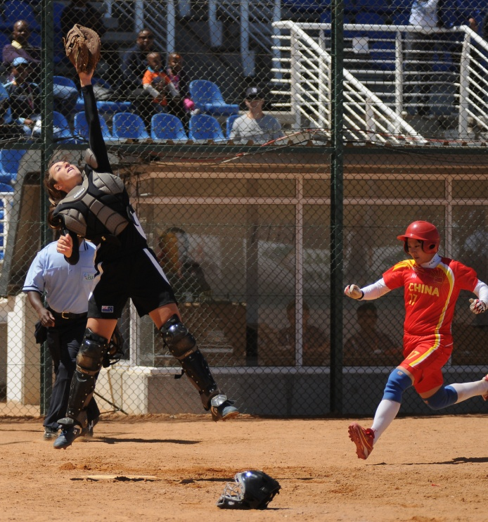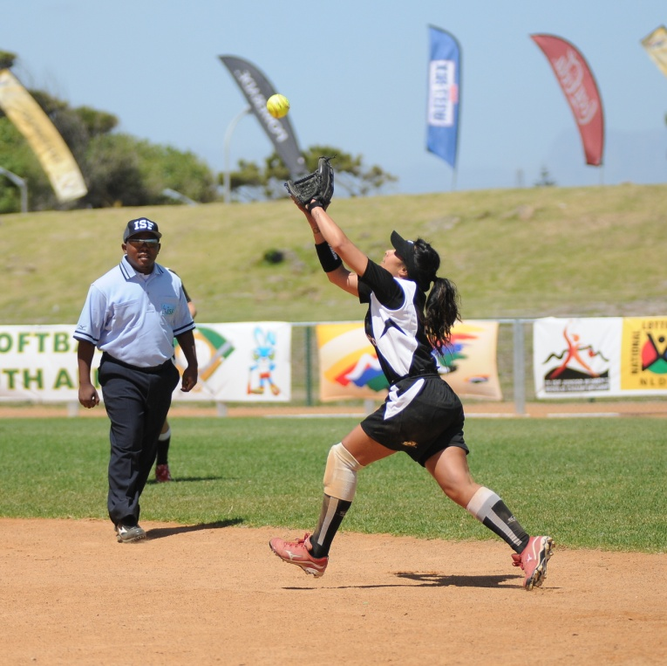

|  |  |  |  |  |  |  |  |  |  |  |  |
| --- | --- | --- | --- | --- | --- | --- | --- | --- | --- | --- | --- |
| **Australia.jpgS:\common\Photo's Scnd Images\15 Logo's\Fern\Black_Sox_Fern.jpgNew Zealand Development Teams (Boys)**  **International Youth Cup**  **Blacktown Sydney**  **New Zealand Development 04th to 8th July 2011** | | | | | | | | | | | |
| *In July 2011, the New Zealand Development teams travelled to Sydney to play in the International Youth Cup in preparation for the Junior World Championships.* | | | | | | | | | | | |
| * Bradley Bennet | | | AK | * Vincent Harris | | | WK | * Tailah Love | | | WN |
| * Cameron Bearman | | | AK | * Taylor Hick | | | NH | * Taylor Nau | | | NH |
| * Peter Dando | | | CM | * Ethan Johnston | | | CB | * Regan O’Neil | | | AK |
| * Eruera Drage | | | NH | * Josh Kahukura | | | CO | * Connor Peden | | | NH |
| * Khalid Gilbert | | | WK | * Dante Matakatea | | | WN | * Horowai Puketapu | | | HB |
| NZ Development Teams (Boys) Management Team | | | | | | | | | | | |
| **Head Coach** | David Reyland | | | | | **Manager** | | | Alan Pumfleet | | |
| **Assistant Coach** | Mel England | | | | | **Scorer** | | | Don Karsten | | |
| Series Results | | | | | | | | | | | |
| Opposition | | Result | | | Runs For | | | | | Runs Against | |
| NSW Country Boys | | Win | | | 11 | | | | | 1 | |
| ISA New Zealand | | Win | | | 3 | | | | | 1 | |
| NSW Metro Boys | | Win | | | 9 | | | | | 0 | |
| Australia 19 Green | | Win | | | 5 | | | | | 2 | |
| Australia 19 Gold | | Loss | | | 1 | | | | | 6 | |
| Australia U17 Boys | | Win | | | 6 | | | | | 3 | |
| Western Civil | | Loss | | | 3 | | | | | 7 | |
| Australia 19 Gold | | Win | | | 4 | | | | | 1 | |
| Western Civil | | Win | | | 2 | | | | | 1 | |
| Australia 19 Green | | Loss | | | 4 | | | | | 5 | |

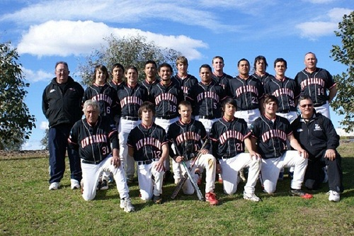



|  |  |  |  |  |  |  |  |  |  |  |  |
| --- | --- | --- | --- | --- | --- | --- | --- | --- | --- | --- | --- |
| **New Zealand Development Teams (Girls)**  **International Youth Cup**  **New Zealand Development Blacktown Sydney**  **04th to 8th July 2011** | | | | | | | | | | | |
| *In July 2011, the New Zealand Development teams travAustralia.jpgelled to Sydney to play in the International Youth Cup in preparation for the Junior World Championships.* | | | | | | | | | | | |
| * Erika Avery | | | AK | * Courtney Gettins | | | HB | * Cassie Siataga | | | CB |
| * Sharma Bradbook | | | HV | * Tyneesha Houkamau | | | AK | * Keri Simeon | | | WN |
| * Leah Conley | | | WN | * Jasmine Kaiaruna | | | WN | * Mikayla Werahiko | | | CB |
| * Teremoana Elliot | | | CB | * Clarissa Mafoe | | | AK | * Matie Whitman | | | HV |
| * Chance Warbrick | | | HV | * Katie McAndrew | | | WN | * Krystal Werahiko | | | CB |
| * Emma Francis | | | WN | * Ariana Namana | | | HV |  | | |  |
| NZ Development Team (Girls) Management Team | | | | | | | | | | | |
| **Head Coach** | Alex Carter | | | | | **Manager** | | | Marnie Barber | | |
| **Assistant Coach** | Angela Johnston | | | | | **Scorer** | | | Elaine Karsten | | |
| **Battery Coach** | Melanie Gettins | | | | |  | | |  | | |
| Series Results | | | | | | | | | | | |
| Opposition | | Result | | | Runs For | | | | | Runs Against | |
| Sunstate Wanderers | | Loss | | | 3 | | | | | 4 | |
| School Sport Australia | | Loss | | | 2 | | | | | 9 | |
| Australia U17 Girls | | Loss | | | 0 | | | | | 10 | |
| NSW Country Girls | | Win | | | 11 | | | | | 1 | |
| NSW Metro Girls | | Win | | | 4 | | | | | 0 | |
| SE Metro Vic | | Win | | | 11 | | | | | 4 | |
| NSW Metro Girls | | Loss | | | 2 | | | | | 7 | |
| SE Metro Vic | | Win | | | 7 | | | | | 3 | |
| Australia U17 Girls | | Loss | | | 4 | | | | | 6 | |
| C:\Users\srobbers\AppData\Local\Microsoft\Windows\Temporary Internet Files\Content.Outlook\ZAIGF2S3\20120720155405505_0001.jpg | |  | | |  | | | | |  | |

## National Tournament Results

### National Fastpitch Championship

|  |  |
| --- | --- |
| ***NFC-Logo-interDate*** | 16th to 19th February 2012 |
| ***Host*** | Wellington |
| ***Venue*** | Fraser Park, Lower Hutt |
| ***NFC Commission*** | Haydn Smith, Deslea Wrathall, Dale Eagar |
| ***Chief Umpire*** | Wayne Saunders |
| ***Chief Scorer*** | Sandy Wallace |
| ***Statistician*** | Elaine Karsten |
| ***Tournament Representative*** | Eugene Gilbert |

|  |  |  |  |  |  |  |  |
| --- | --- | --- | --- | --- | --- | --- | --- |
| **MEN’S NFC FINAL STANDINGS** | | | | | | | |
| **1** | Auckland | | S:\Naomi\My Pictures SNZ photos\National Tournaments\12NFC\IMG_0319 (2)_edited-1.jpg | | | | |
| **2** | Canterbury | |
| **3** | Wellington | |
| **4** | Hawkes Bay | |
| **5** | Japan Universities | |
| **6** | Hutt Valley | |
| **7** | North Harbour | |
| **8** | Southern Pride | |
| **9** | Counties Manukau/Waikato | |
| **MEN’S NFC INDIVIDUAL AWARDS** | | | | | | |
| **MVP** | | **Heinrick Shannon** | | **AK** |  | **Heinie.jpgS:\common\Photo's Scnd Images\01 Black Sox\2009\Black Sox2009WC\Black Sox Head & Shoulders\Nathan Nukunuku.jpg** |
| **Top Batter** | | **Nathan Nukunuku** | | **AK** | **AVG**  **0.538** | **Heinie.jpg** |
| **Top Pitcher** | | **Heinrick Shannon** | | **AK** | **ERA**  **1.31** |  |

|  |  |  |
| --- | --- | --- |
| **S:\Naomi\My Pictures SNZ photos\National Tournaments\12FebNFCWmn\2012_02_19\IMG_5504.JPGWOMEN’S NFC FINAL STANDINGS** | | |
| **1** | Auckland |  |
| **2** | Hutt Valley |
| **3** | Canterbury |
| **4** | Southern Pide |
| **5** | Wellington |
| **6** | Counties-Manukau/Waikato |  |

|  |  |  |  |  |
| --- | --- | --- | --- | --- |
| **S:\common\Photo's Scnd Images\02 White Sox\2009\White Sox Aussie Test Series 09 Images\DSC_6769.JPGWOMEN’S NFC INDIVIDUAL AWARDS** | | | | |
| **MVP** | **Michal Tangaroa** | **AK** |  | **S:\common\Photo's Scnd Images\04 JNR White Sox\2011\Best Pictures JWS WORLDS 2011\Best INDIVIDUALS\Danica Ferriso.JPG** |
| **Top Batter** | **Danica Ferriso** | **HV** | **AVG**  **0.478** |  |
| **Top Pitcher** | **Michal Tangaroa** | **AK** | **ERA**  **0.68** | **S:\common\Photo's Scnd Images\02 White Sox\2009\White Sox Aussie Test Series 09 Images\DSC_6769.JPG** |

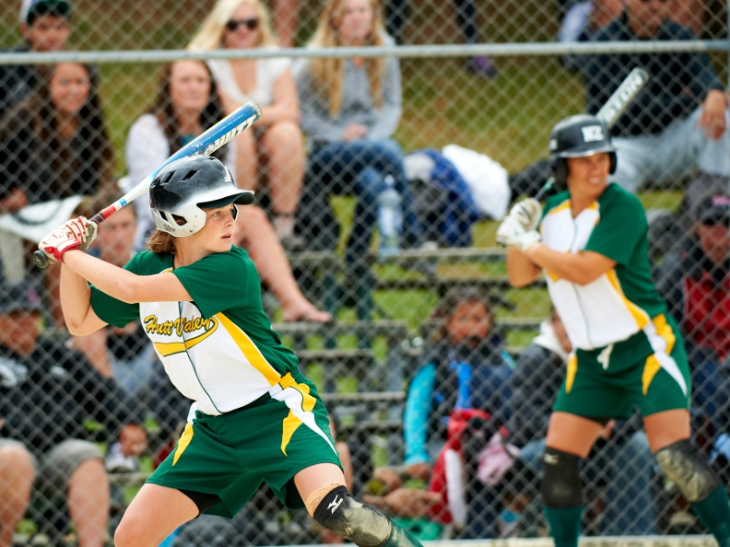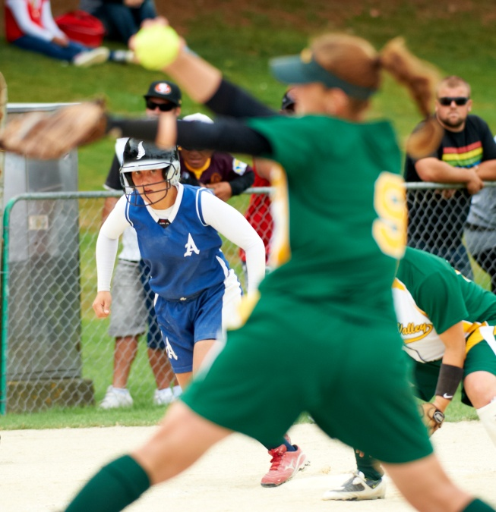

Images courtesy of Jun Tanlayco Sports Images

### Men’s Open Club Championship

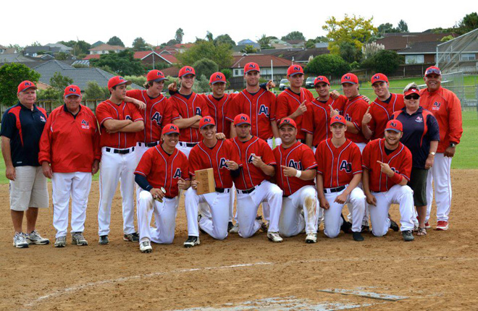

|  |  |
| --- | --- |
| ***Date*** | 13th to 17th March 2012 |
| ***Host*** | Auckland |
| ***Venue*** | Meadowlands Reserve |
| ***Chief Umpire*** | Wayne Saunders |
| ***Chief Scorer*** | Lil Natana |
| ***Statistician*** | Pat Hannah, Carolyn McQueen |
| ***Tournament Representative*** | Cowley Harris |

Photo courtesy of Sharon Ford

|  |  |  |  |
| --- | --- | --- | --- |
| **MEN’S OPEN CLUB NATIONAL FINAL STANDINGS** | | | |
| **1** | Auckland United | **12** | Hawkes Bay Fastpitch |
| **2** | Poneke Kilbirnie | **13** | Howick |
| **3** | Waitakere Bears | **14** | Eden Roskill |
| **4** | Mt Albert Ramblers | **15** | Porirua City United |
| **5** | Richmond Keas | **16** | Auckland Marist |
| **6** | Northcote | **17** | Hutt Valley Cardinals |
| **7** | PCU Devils | **18** | Hutt Valley Marist |
| **8** | Miramar | **19** | Johnsonville |
| **9** | Papanui | **20** | Marlinz |
| **10** | Hutt Valley Dodgers | **21** | Redhill Rockets |
| **11** | Roosters |  |  |

|  |  |  |  |  |
| --- | --- | --- | --- | --- |
| **MEN’S OPEN CLUB NATIONAL INDIVIDUAL AWARDS**  **C:\Documents and Settings\DDoughan\Local Settings\Temporary Internet Files\Content.Word\Thomas Enoka.jpg** | | | | |
| **MVP** | **Thomas Enoka** | **Auckland United** |  | **Daniel-Tarapi-10162_048.jpg** |
| **Top Batter** | **Daniel Tarapi** | **Poneke Kilbirnie** | **AVG**  **0.571** |  |
| **Top Pitcher** | **Heinie Shannon** | **Bears** | **ERA**  **0.64** | **Heinie.jpg** |

### Women’s Open Club Championship

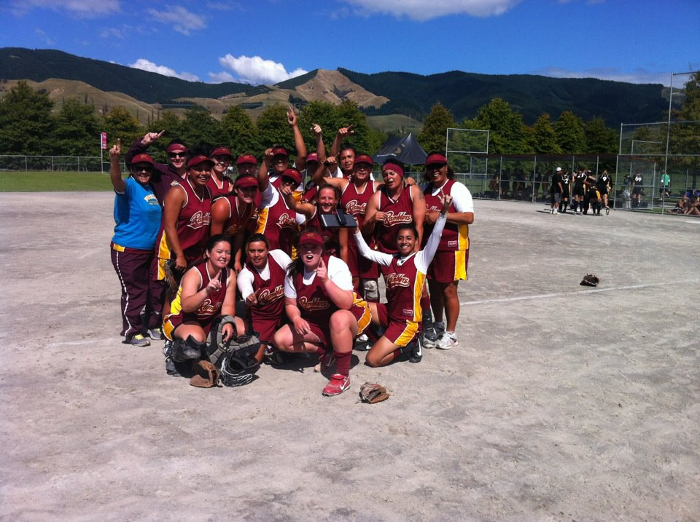

|  |  |
| --- | --- |
| ***Date*** | 14th to 17th March 2012 |
| ***Host*** | Nelson |
| ***Venue*** | Saxton Fields, Nelson |
| ***Chief Umpire*** | Nicola Ogier |
| ***Chief Scorer*** | Sharon Williams |
| ***Statistician*** | Vicky Griffiths |
| ***Tournament Representative*** | Marnie Barber |

|  |  |  |  |
| --- | --- | --- | --- |
| **WOMEN’S OPEN CLUB NATIONAL FINAL STANDINGS** | | | |
| **1** | Mt Albert Ramblers | **9** | Richmond |
| **2** | Waitakere Bears | **10** | Albion |
| **3** | Western Magpies | **11** | Porirua City United |
| **4** | Te Aroha | **12** | Howick |
| **5** | Johnsonville | **13** | Saints |
| **6** | Otahuhu | **14** | Newlands |
| **7** | Auckland Marist | **15** | Stoke |
| **8** | Papanui |  |  |

|  |  |  |  |  |
| --- | --- | --- | --- | --- |
| **cid:image003.jpg@01CD68C1.7ECEEEC0WOMEN’S OPEN CLUB NATIONAL INDIVIDUAL AWARDS** | | | | |
| **MVP** | **Rebecca Hicks** | **Western Magpies** |  |  |
| **Top Batter** | **Rebecca Hicks** | **Western Magpies** | **AVG**  **.640** | **cid:image003.jpg@01CD68C1.7ECEEEC0** |
| **Top Pitcher** | **Michal Tangaroa** | **Waitakere Bears** | **ERA**  **0.48** | **S:\common\Photo's Scnd Images\02 White Sox\2009\White Sox Aussie Test Series 09 Images\DSC_6769.JPG** |

### U/19 National Tournament

|  |  |  |  |  |  |  |
| --- | --- | --- | --- | --- | --- | --- |
| **Boys** | | |  | **Girls** | | |
| *Date* | | 5-8 January 2012 |  | *Date* | | 5-8 January 2012 |
| *Host* | | Canterbury |  | *Host* | | Auckland |
| *Venue* | | Mainland Foundation Ballpark |  | *Venue* | | Starling Park |
| *Chief Umpire* | | Mark McFarlane |  | *Chief Umpire* | | Cass Seeling |
| *Chief Scorer* | | Sandy Wallace |  | *Chief Scorer* | | Ronnie Gurney |
| *Statistician* | | Marie Byrne |  | *Statistician* | | Tracee Topia |
| *Tournament Representative* | | Cowley Harris |  | *Tournament Representative* | | Venita Hokai |
| *Tournament Selector* | | John Love |  | *Tournament Selector* | | Rob Cardwell |
| **Trophy Winners - Boys** | | |  | **Trophy Winners - Girls** | | |
| *Winners* | North Harbour | |  | *Winners* | Wellington | |
| *Runners Up* | Hutt Valley | |  | *Runners Up* | Auckland A | |

|  |  |  |  |  |  |  |  |  |
| --- | --- | --- | --- | --- | --- | --- | --- | --- |
| **Individual Awards – Boys** | | | |  | **Individual Awards - Girls** | | | |
|  |  |  | AVG |  |  |  |  | AVG |
| *Top Batter* | Tamihana Nau | **NH** | 0.667 |  | *Top Batter* | Tyneesha Houkamau | **AK** | .632 |
| *Top Pitcher* | Joshua Pettett | **NH** | 1.88 |  | *Top Pitcher* | Jordan Leigh Koni | **AK** | 0.00 |
| *Top Catcher* | Taylor Hick | **NH** |  |  | *Top Catcher* | Emma Houkamau | **HB** |  |
| *MVP* | Tamihana Nau | **NH** |  |  | *MVP* | Jordan Leigh Koni | **AK** |  |

|  |  |  |  |  |  |  |  |  |
| --- | --- | --- | --- | --- | --- | --- | --- | --- |
| **Final Standings – Boys** | | | |  | **Final Standings - Girls** | | | |
| 1 | North Harbour | 5 | Hawkes Bay |  | 1 | Wellington | 5 | Auckland Development |
| 2 | Hutt Valley | 6 | Southland |  | 2 | Auckland A | 6 | Hutt Valley |
| 3 | Wellington | 7 | Canterbury |  | 3 | Hawkes Bay | 7 | Waikato |
| 4 | Auckland | 8 | Upper South Island |  | 4 | Canterbury | 8 | North Harbour |

|  |  |  |  |  |  |  |
| --- | --- | --- | --- | --- | --- | --- |
| **Tournament Team – Boys** | | |  | **Tournament Team - Girls** | | |
| Josh Pettett | | **NH** |  | Jordan Leigh Koni | | **AK** |
| Bradley Worsley | | **HV** |  | Beth Stavert | | **AK** |
| Kurt Schollum | | **WN** |  | Jasmin Kaiaruna | | **WN** |
| Matt Oxley | | **AK** |  | Santana Harris | | **AK** |
| Taylor Hick | | **NH** |  | Emma Houkamau | | **HB** |
| Tailah Love | | **WN** |  | Keri-Moana Simeon | | **WN** |
| Pita Rona | | **NH** |  | Lydia Koko-Latau | | **WN** |
| Reagan O’Neill | | **AK** |  | Jardene Tipa | | **WN** |
| Joseph Ferriso | | **HV** |  | Keeley Wells | | **AK** |
| Tamihana Nau | | **NH** |  | Kingsley Avery | | **AK** |
| Hohepa Monk | | **WK** |  | Tyneesha Houkamau | | **AK** |
| Campbell Ngarimu | | **HV** |  | Ashley Puckett | | **CB** |
| Josh Dickson | | **CB** |  | Matie Whitman | | **HV** |
| Jerome Raemaki | | **WN** |  | Aroha Noanoa | | **WN** |
| **Coach** | Danny Knight | **NH** |  | **Coach** | Alex Carter | **WN** |
| **Manager** | Margaret Marsh | **HV** |  | **Manager** | Beth Avery | **CB** |

### U/17 National Tournament

|  |  |  |  |  |  |  |
| --- | --- | --- | --- | --- | --- | --- |
| **Boys** | | |  | **Girls** | | |
| *Date* | | 12-19 January 2012 |  | *Date* | | 12-19 January 2012 |
| *Host* | | Wellington |  | *Host* | | Canterbury |
| *Venue* | | Atiawa Park, Paraparaumu |  | *Venue* | | Mainland Foundation Ballpark |
| *Chief Umpire* | | Wiremu Tamaki |  | *Chief Umpire* | | Nicola Ogier |
| *Chief Scorer* | | Raewyn Fergusson |  | *Chief Scorer* | | Russell Moffatt |
| *Statistician* | | Christine Nukunuku |  | *Statistician* | | Vicky Griffiths |
| *Tournament Representative* | | Marnie Barber |  | *Tournament Representative* | | Naomi Shaw |
| *Tournament Selector* | | Mel England |  | *Tournament Selector* | | Naomi Shaw |
| **Trophy Winners - Boys** | | |  | **Trophy Winners - Girls** | | |
| *Winners* | Waikato | |  | *Winners* | Hawkes Bay | |
| *Runners Up* | Hawkes Bay | |  | *Runners Up* | Auckland | |

|  |  |  |  |  |  |  |  |  |
| --- | --- | --- | --- | --- | --- | --- | --- | --- |
| **Individual Awards – Boys** | | | |  | **Individual Awards - Girls** | | | |
|  |  |  | AVG |  |  |  |  | AVG |
| *Top Batter* | Jackson Baird-Gillet | **WK** | .700 |  | *Top Batter* | Mereana Monk | **HB** | .522 |
| *Top Pitcher* | Blake Radford | **HB** | 2.24 |  | *Top Pitcher* | Courtney Gettins | **HB** | 0.60 |
| *Top Catcher* | Callum Elson | **HB** |  |  | *Top Catcher* | Emma Francis | **WN** |  |
| *MVP* | Toa Tauranga | **WK** |  |  | *MVP* | Courtney Gettins | **HB** |  |

|  |  |  |  |  |  |  |  |  |
| --- | --- | --- | --- | --- | --- | --- | --- | --- |
| **Final Standings – Boys** | | | |  | **Final Standings - Girls** | | | |
| 1 | Waikato | 7 | Canterbury |  | 1 | Hawkes Bay | 4 | Canterbury |
| 2 | Hawkes Bay | 8 | Upper South Island |  | 2 | Auckland | 5 | Upper South Island |
| 3 | Wellington | 9 | Southland |  | 3 | Wellington | 6 | Southland |
| 4 | Auckland | 10 | Wanganui |  | S:\Naomi\My Pictures SNZ photos\National Tournaments\12JanU17GNationals\IMG_7210.JPG |  |  |  |
| 5 | North Harbour | 11 | Otago |  |  |  |  |  |
| 6 | Hutt Valley | 12 | Manawatu |  |  |  |  |  |

U17 Girls Tournament Team

|  |  |  |  |  |  |  |
| --- | --- | --- | --- | --- | --- | --- |
| **Tournament Team – Boys** | | |  | **Tournament Team - Girls** | | |
| Blake Radford | | **HB** |  | Couteney Gettins | | **HB** |
| Eruera Drage | | **NH** |  | Tyneesha Houkamau | | **AK** |
| Jackson Baird-Gillet | | **WK** |  | Sharnae Walsh | | **CB** |
| Jared Elliot | | **WN** |  | Emma Francis | | **WN** |
| Callum Elson | | **HB** |  | Emma Houkamau | | **HB** |
| Nopera Stockford | | **WN** |  | Samantha Cooper | | **HB** |
| Joshua Smith | | **HB** |  | Keri-Moana Simeon | | **WN** |
| Toa Tauranga | | **WK** |  | Mikayla Werahiko | | **CB** |
| Sam Selby-Law | | **MW** |  | Kuraroa Ratu-James | | **HB** |
| Vincent Harris | | **WK** |  | Kayla Rangiawha | | **WN** |
| Te Kahui Bishop | | **WN** |  | Melanie Gallagher | | **AK** |
| Bradley Bennett | | **AK** |  | Ashlyn Obers | | **HB** |
| Taniera Miritana | | **HB** |  | Lisei Le’aupepe | | **WN** |
| Dimitri Morunga | | **AK** |  | Mereana Monk | | **HB** |
|  | |  |  | Sapphire Ngaronga | | **AK** |
| **Coach** | Cowley Harris |  |  | **Coach** | Alex Carter | **WN** |
| **Manager** | Marie Prime |  |  | **Manager** | Beth Avery | **CB** |

|  |  |  |  |  |  |  |
| --- | --- | --- | --- | --- | --- | --- |
| **Rest Team – Boys** | | |  |  | | |
| Thomas Gillard | | **HV** |  | S:\common\Photo's Scnd Images\08 Tournaments\07 U17 Boys\2012\IMG_0764.JPG | |  |
| Kemara Hauiti-Parapara | | **WN** |  |  | |  |
| Ethan Johnston | | **CB** |  |  | |  |
| Jacob Oxley | | **MW** |  |  | |  |
| Connor Peden | | **NH** |  |  | |  |
| Mitchell Finnie | | **OT** |  |  | |  |
| Jacob Hafford | | **NH** |  |  | |  |
| Tyler Bird | | **USI** |  |  | |  |
| Stirling Bartlett | | **HB** |  |  | |  |
| Murphy Albright | | **HV** |  |  | |  |
| Jarrod Adams | | **HV** |  |  | |  |
| Tiwana Aranui | | **HB** |  |  | |  |
| Shaun Rutherford | | **NH** |  |  | |  |
| Josh Kahukura | | **SL** |  |  | |  |
| Luke Cummings | | **WN** |  |  | |  |
| **Coach** | Corey Tamati |  |  |  |  |  |
| **Manager** | Maria Baird |  |  |  |  |  |

### U/15 North Island Interprovincial Championship

|  |  |  |  |  |  |  |
| --- | --- | --- | --- | --- | --- | --- |
| **Boys** | | |  | **Girls** | | |
| *Date* | | 12-15 January 2012 |  | *Date* | | 12-15 January 2012 |
| *Host* | | Wanganui |  | *Host* | | Western BOP |
| *Venue* | | Braves Ballpark |  | *Venue* | | Tauranga Domain |
| *Chief Umpire* | | Lindsay Edwards |  | *Chief Umpire* | | Cass Seeling |
| *Chief Scorer* | | Cat Hancock |  | *Chief Scorer* | | Tracee Topia |
| *Statistician* | | Coralie Davies |  | *Statistician* | | Lil Natana |
| *Tournament Representative* | | Venita Hokai |  | *Tournament Representative* | | Marnie Barber |
| *Tournament Selector* | | Mel England |  | *Tournament Selector* | | Koro Amai |
| **Trophy Winners - Boys** | | |  | **Trophy Winners - Girls** | | |
| *Winners* | Wellington | |  | *Winners* | Auckland | |
| *Runners Up* | Auckland | |  | *Runners Up* | Wellington | |

|  |  |  |  |  |  |  |  |  |
| --- | --- | --- | --- | --- | --- | --- | --- | --- |
| **Individual Awards – Boys** | | | |  | **Individual Awards - Girls** | | | |
|  |  |  | AVG |  |  |  |  | AVG |
| *Top Batter* | Danny Brown | **HV** | 0.533 |  | *Top Batter* | Deaven Tavalu | **AK** | .680 |
| *Top Pitcher* | Kemara Hauiti-Parapa | **WN** | 0.00 |  | *Top Pitcher* | Yolandra Roberts | **NH** | 1.20 |
| *Top Catcher* | Eric Munroe | **AK** |  |  | *Top Catcher* | Ella Cameron | **HV** |  |
| *MVP* | Dante Matakatea | **WN** |  |  | *MVP* | Tyla Morrison | **AK** |  |

|  |  |  |  |  |  |  |  |  |
| --- | --- | --- | --- | --- | --- | --- | --- | --- |
| **Final Standings – Boys** | | | |  | **Final Standings - Girls** | | | |
| 1 | Wellington | 7 | Manawatu |  | 1 | Auckland | 5 | Sydney Metro All Stars |
| 2 | Auckland | 8 | Wellington Development |  | 2 | Wellington | 6 | North Harbour |
| 3 | Hutt Valley | 9 | Auckland Development |  | 3 | Hutt Valley | 7 | Hawkes Bay |
| 4 | Hawkes Bay | 10 | Waikato |  | 4 | Waikato | 8 | Counties-Manukau |
| 5 | Counties Manukau | 11 | Wanganui |  |  |  |  |  |
| 6 | North Harbour |  |  |  |  |  |  |  |

|  |  |  |  |  |  |  |
| --- | --- | --- | --- | --- | --- | --- |
| **Tournament Team – Boys** | | |  | **Tournament Team - Girls** | | |
| Kemara Hauiti-Parapara | | **WN** |  | Te Awhina Plumridge | | **HV** |
| Daniel Chapman | | **AK** |  | Yolandra Roberts | | **NH** |
| Seth Bourgeois | | **AK** |  | Kaleeya Matai | | **AK** |
| Eric Munroe | | **AK** |  | Emma Houkamau | | **HB** |
| Jacob Zurcher | | **HB** |  | Ella Cameron | | **HV** |
| Giovanni Timoti | | **CM** |  | Courtney Elliot | | **WK** |
| Dante Matakatea | | **WN** |  | Mereana Makea | | **WN** |
| Cameron Meyer | | **AK** |  | Alana Rahui | | **HB** |
| Cole Evans | | **AK** |  | Kanyon Paul | | **WK** |
| Sam Selby-Law | | **MW** |  | Tyla Morrison | | **AK** |
| Luke Cummings | | **WN** |  | Brooke Calverley | | **CM** |
| Sione Gray | | **WN** |  | Makayla Mave | | **AK** |
| Murphy Newton | | **CM** |  | Marama Makea | | **WN** |
| Murphy Albright | | **HV** |  | Aria Tawha | | **WK** |
| Nirvada Newton | | **CM** |  | Deaven Tavalu | | **AK** |
| Harrison Mei | | **AK** |  |  | |  |
| Danny Brown | | **HV** |  |  | |  |
| **Coach** | Thomas Makea | **WN** |  | **Coach** | Gina Marcum | **WN** |
| **Manager** | Marissa Smith | **CM** |  | **Manager** | Lunn-Hing Matai | **AK** |

*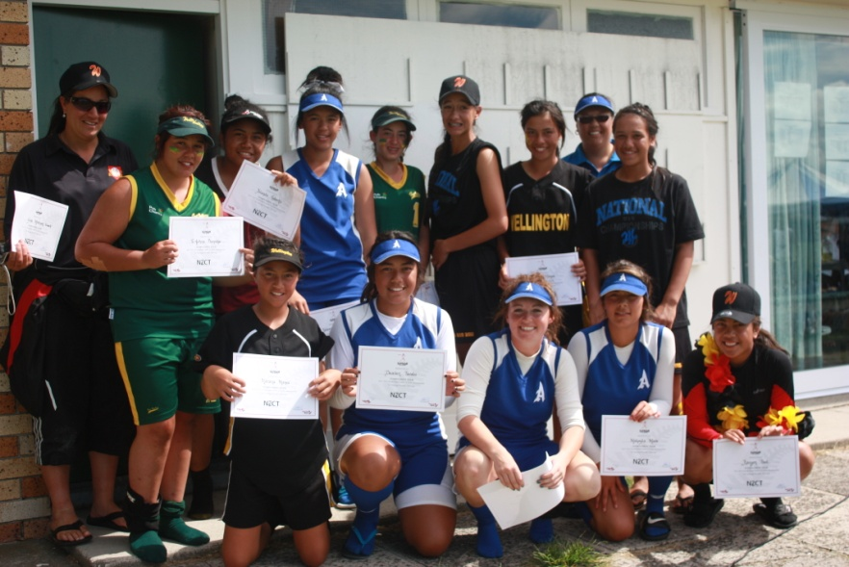*

The U15 Girls Tournament Team

### U/15 South Island Interprovincial Championship

|  |  |  |  |  |  |  |
| --- | --- | --- | --- | --- | --- | --- |
| **Boys** | | |  | **Girls** | | |
| *Date* | | 12-15 January 2012 |  | *Date* | | 12-15 January 2012 |
| *Host* | | Marlborough |  | *Host* | | Marlborough |
| *Venue* | | A & P Showgrounds |  | *Venue* | | A & P Showgrounds |
| *Chief Umpire* | | Wiremu Tamaki |  | *Chief Umpire* | | Wiremu Tamaki |
| *Chief Scorer* | | Ima Hodges |  | *Chief Scorer* | | Ima Hodges |
| *Statistician* | | Ian Ditfort |  | *Statistician* | | Di Tulloch |
| *Tournament Representative* | | Eugene Gilbert |  | *Tournament Representative* | | Eugene Gilbert |
| *Tournament Selector* | | John Lowes |  | *Tournament Selector* | | Glen Metcalf |
| **Trophy Winners - Boys** | | |  | **Trophy Winners - Girls** | | |
| *Winners* | Canterbury | |  | *Winners* | Canterbury | |
| *Runners Up* | Central Otago | |  | *Runners Up* | Marlborough | |

|  |  |  |  |  |  |  |  |  |
| --- | --- | --- | --- | --- | --- | --- | --- | --- |
| **Individual Awards – Boys** | | | |  | **Individual Awards - Girls** | | | |
|  |  |  | AVG |  |  |  |  | AVG |
| *Top Batter* | Callum Bishop | **CB** | .640 |  | *Top Batter* | Liberty Bent | **CB** | .833 |
| *Top Pitcher* | Bailey Hamilton | **CB** | 0.39 |  | *Top Pitcher* | Sarah Carter | **CB** | 0.89 |
| *Top Catcher* | Jackson Watt | **CB** |  |  | *Top Catcher* | Liberty Bent | **CB** |  |
| *MVP* | Bailey Hamilton | **CB** |  |  | *MVP* | Lorin Cook | **MB** |  |

|  |  |  |  |  |  |  |  |  |
| --- | --- | --- | --- | --- | --- | --- | --- | --- |
| **Final Standings – Boys** | | | |  | **Final Standings - Girls** | | | |
| 1 | Canterbury | 4 | Marlborough |  | 1 | Canterbury | 4 | Central Otago |
| 2 | Central Otago | 5 | Southland |  | 2 | Marlborough | 5 | Otago |
| 3 | Nelson | 6 | Otago |  | 3 | Eastern Southland | 6 | Southland |
|  |  |  |  |  |  |  |  |  |

|  |  |  |  |  |  |  |
| --- | --- | --- | --- | --- | --- | --- |
| **Tournament Team – Boys** | | |  | **Tournament Team - Girls** | | |
| Bailey Hamilton | | **CB** |  | Sarah Carter | | **CB** |
| Callum Bishop | | **CB** |  | Amy Begg | | **CB** |
| Tyler Cameron | | **CO** |  | Lorin Cook | | **MB** |
| Jackson Watt | | **CB** |  | Liberty Bent | | **CB** |
| Caleb Davies | | **CO** |  | Savannah Ward | | **CB** |
| Robbie Clink | | **CB** |  | Alexandra King | | **CB** |
| Daniel Keen | | **SL** |  | Tia Marie Tuhakaraina | | **ES** |
| Brody Bishop | | **CB** |  | Tessa Metuatini | | **CB** |
| Lincoln McBride | | **NN** |  | Nerissa McDowell | | **MB** |
| Hamish Lewos | | **OG** |  | Jayda Taiepa | | **CB** |
| Nixon Kim | | **MB** |  | Bohemian Quinn | | **CB** |
| Lewis Clarke | | **NN** |  | Lucy McIntyre | | **SL** |
| Hunter Martin | | **CB** |  | Caitlin Davidson | | **CB** |
| Thomas Grey | | **SL** |  | Maddison Broomhall | | **CB** |
| Isaac Kahukura | | **CO** |  | Maraea Kennedy-Tenali | | **ES** |
|  | |  |  | Jordan Peipi | | **MB** |
| **Coach** | Gary Andrews | **CB** |  | **Coach** | Christina Elliot | **CB** |
| **Assistant** | Wayne Dove | **CB** |  | **Assistant** | Anthea Stringer | **MB** |
| **Manager** | Nicola Herbert | **OG** |  | **Manager** | Jackie Cross | **OG** |

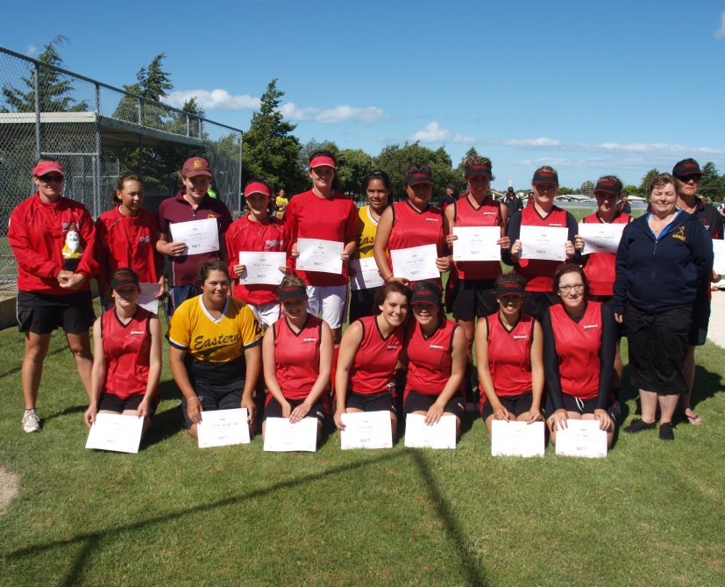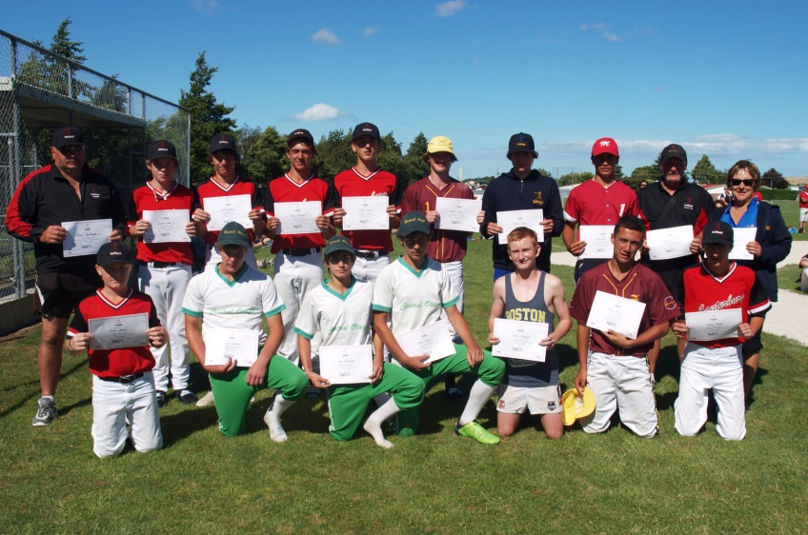

U15 South Island Tournament Teams

### Pak n Save New Zealand Secondary Schools Division 1 Championship

|  |  |  |  |  |  |  |  |  |  |  |  |  |  |  |  |  |  |
| --- | --- | --- | --- | --- | --- | --- | --- | --- | --- | --- | --- | --- | --- | --- | --- | --- | --- |
| **Boys** | | | | | | | | |  | **Girls** | | | | | | | |
| *Date* | | | | 26-30 March 2012 | | | | |  | *Date* | | | | 26-30 March 2012 | | | |
| *Host* | | | | Hutt Valley | | | | |  | *Host* | | | | Hutt Valley | | | |
| *Venue* | | | | Fraser Park, Lower Hutt | | | | |  | *Venue* | | | | Fraser Park, Lower Hutt | | | |
| *Chief Umpire* | | | | Dennis Smith | | | | |  | *Chief Umpire* | | | | Dennis Smith | | | |
| *Chief Scorer* | | | | Elaine Karsten | | | | |  | *Chief Scorer* | | | | Elaine Karsten | | | |
| *Statistician* | | | | Lil Natana | | | | |  | *Statistician* | | | | Karen Walford | | | |
| *Tournament Representative* | | | | Marnie Barber | | | | |  | *Tournament Representative* | | | | Marnie Barber | | | |
| *Tournament Selector* | | | | Eugene Gilbert | | | | |  | *Tournament Selector* | | | | Alex Carter | | | |
| **Trophy Winners - Boys** | | | | | | | | |  | **Trophy Winners - Girls** | | | | | | | |
| *Winners* | | Marlborough Boys High School | | | | | | |  | *Winners* | | Newlands College | | | | | |
| *Runners Up* | | Massey High School | | | | | | |  | *Runners Up* | | Green Bay High School | | | | | |
| **Individual Awards – Boys** | | | | | | | | |  | **Individual Awards - Girls** | | | | | | | |
|  | |  | | | |  | AVG | |  |  | |  | | | |  | AVG |
| *Top Batter* | | Horowai Puketapu | | | |  | .667 | |  | *Top Batter* | | Danica Ferriso | | | |  | .708 |
| *Top Pitcher* | | Kurt Schollum | | | |  | 0.89 | |  | *Top Pitcher* | | Beth Stavert | | | |  | 1.67 |
| *Top Catcher* | | Taylor Hick | | | |  |  | |  | *Top Catcher* | | Emma Francis | | | |  |  |
| *MVP* | | Kurt Schollum | | | |  |  | |  | *MVP* | | Emma Francis | | | |  |  |
| **Final Standings – Boys** | | | | | | | |  | | **Final Standings - Girls** | | | | | | | | |
| 1 | Marlborough Boys High School | | 6 | | Napier Boys High | | |  | | 1 | Newlands College | | 6 | | Naenae College | | | |
| 2 | Massey High School | | 7 | | St Patricks Silverstream | | |  | | 2 | Green Bay High School | | 7 | | Avondale College | | | |
| 3 | Mt Albert Grammar | | 8 | | Rongotai College | | |  | | 3 | Hamilton Girls High | | 8 | | Epsom Girls Grammar | | | |
| 4 | Hamilton Boys High | | 9 | | Nelson College | | |  | | 4 | Sacred Heart College, Lower Hutt | | 9 | | Upper Hutt College | | | |
| 5 | Wellington College | | 10 | | Tawa College | | |  | | 5 | Wellington East Girls | |  | |  | | | |

|  |  |  |  |  |  |  |
| --- | --- | --- | --- | --- | --- | --- |
| **Tournament Team – Boys** | | |  | **Tournament Team - Girls** | | |
| Kurt Schollum | | **MB** |  | Beth Stavert | | **AK** |
| Eruera Drage | | **NH** |  | Tyler Downs | | **WK** |
| Dylan Hayes | | **HV** |  | Emma Francis | | **WN** |
| Taylor Hick | | **AK** |  | Sharelle Leota | | **AK** |
| Khalid Gilbert | | **WK** |  | Loran Parker | | **AK** |
| Tailah Love | | **HV** |  | Jade Fraser | | **WN** |
| Joel Mitchell | | **HB** |  | Sapphire Ngaronga | | **AK** |
| Jacob Oxley-Devlin | | **AK** |  | Danica Ferriso | | **HV** |
| Horowai Puketapu | | **HB** |  | Morgan Gilmour | | **AK** |
| Daniel Mallabar | | **NN** |  | Freya Bulloch | | **AK** |
| Vincent Harris | | **WK** |  | Leilani Tuimavave-Wines | | **HV** |
| Bradley Bennett | | **AK** |  | Lisei Le’aupepe | | **WN** |
| Taylor Nau | | **AK** |  | Pania Monk | | **WK** |
| Cameron Crofts | | **WN** |  | Mereanna Monk | | **WK** |
| Jerome Raemaki | | **WN** |  | Anne Forster | | **HV** |
| **Coach** | Graham De Boo |  |  | **Coach** | Jennifer Feret |  |
| **Manager** | Donna Devlin |  |  | **Manager** | Debbie Mills |  |

### North Island Secondary Schools Division Two Championship

|  |  |  |  |  |  |  |  |  |  |  |  |  |  |
| --- | --- | --- | --- | --- | --- | --- | --- | --- | --- | --- | --- | --- | --- |
| **Boys** | | | | | | |  | **Girls** | | | | | |
| *Date* | | | | 27-30 March 2012 | | |  | *Date* | | | | 27-30 March 2012 | |
| *Host* | | | | Manawatu | | |  | *Host* | | | | Manawatu | |
| *Venue* | | | | Colquhoun Park, Palmerston North | | |  | *Venue* | | | | Colquhoun Park, Palmerston North | |
| *Chief Umpire* | | | | Ray Dyason | | |  | *Chief Umpire* | | | | Ray Dyason | |
| *Tournament Representative* | | | | Raewyn Judson | | |  | *Tournament Representative* | | | | Raewyn Judson | |
| **Trophy Winners - Boys** | | | | | | |  | **Trophy Winners - Girls** | | | | | |
| *Winners* | | Hastings Boys High | | | | |  | *Winners* | | Pakuranga College | | | |
| *Runners Up* | | Wanganui Boys High | | | | |  | *Runners Up* | | Hastings Girls High | | | |
| **Final Standings – Boys** | | | | | |  | | **Final Standings - Girls** | | | | | | |
| 1 | Hastings Boys High | | 6 | | Aotea College |  | | 1 | Pakuranga College | | 5 | | One Tree Hill College | |
| 2 | Wanganui Boys High | | 7 | | Freyberg High |  | | 2 | Hastings Girls High | | 6 | | Wanganui High School | |
| 3 | St Patricks College Wellington | | 8 | | Gisborne Boys High |  | | 3 | Napier Girls High | | 7 | | Turakina Maori Girls College | |
| 4 | Palmerston North Boys High | | 9 | | Hato Paora College |  | | 4 | Orewa College | |  | |  | |
| 5 | Orewa College | | 10 | | Feilding High School |  | |  |  | |  | |  | |

### South Island Secondary Schools Division Two Championship

|  |  |  |  |  |  |  |  |  |  |  |  |  |  |
| --- | --- | --- | --- | --- | --- | --- | --- | --- | --- | --- | --- | --- | --- |
| **Boys** | | | | | | |  | **Girls** | | | | | |
| *Date* | | | | 27-30 March 2012 | | |  | *Date* | | | | 27-30 March 2012 | |
| *Host* | | | | Southland | | |  | *Host* | | | | Southland | |
| *Venue* | | | | Molyneux Park, Alexandra | | |  | *Venue* | | | | Molyneaux Park, Alexandra | |
| *Chief Umpire* | | | | Dave Beaumont | | |  | *Chief Umpire* | | | | Dave Beaumont | |
| *Tournament Representative* | | | | Valmai Breen | | |  | *Tournament Representative* | | | | Valmai Breen | |
| **Trophy Winners - Boys** | | | | | | |  | **Trophy Winners - Girls** | | | | | |
| *Winners* | | Otago Boys High | | | | |  | *Winners* | | Hillmorton High | | | |
| *Runners Up* | | Dunstan High School | | | | |  | *Runners Up* | | Dunstan High School | | | |
| **Final Standings – Boys** | | | | | |  | | **Final Standings - Girls** | | | | | | |
| 1 | Otago Boys High | | 5 | | Southland Boys High |  | | 1 | Hillmorton High | | 4 | | Maniototo Area School | |
| 2 | Dunstan High School | | 6 | | Waitaki Boys High |  | | 2 | Dunstan High | | 5 | | Ashburton College | |
| 3 | Kings High School | | 7 | | Ashburton College |  | | 3 | St Peters College | |  | |  | |
| 4 | Waimea College | |  | |  |  | |  |  | |  | |  | |

### New Zealand Junior Secondary Schools Championship

|  |  |  |  |  |  |  |  |  |  |  |  |  |  |
| --- | --- | --- | --- | --- | --- | --- | --- | --- | --- | --- | --- | --- | --- |
| **Boys** | | | | | | |  | **Girls** | | | | | |
| *Date* | | | | 28 Nov to 1 Dec 2011 | | |  | *Date* | | | | 28 Nov to 1 Dec 2011 | |
| *Host* | | | | Waikato | | |  | *Host* | | | | Waikato | |
| *Venue* | | | | Resthills Park, Hamilton | | |  | *Venue* | | | | Resthills Park, Hamilton | |
| *Chief Umpire* | | | | Dennie Smith | | |  | *Chief Umpire* | | | | Dennis Smith | |
| *Chief Scorer* | | | | Elaine Karsten | | |  | *Chief Scorer* | | | | Elaine Karsten | |
| *Tournament Representative* | | | | Marnie Barber | | |  | *Tournament Representative* | | | | Marnie Barber | |
| *Tournament Selector* | | | | Eugene Gilbert | | |  | *Tournament Selector* | | | | Alex Carter | |
| **Trophy Winners - Boys** | | | | | | |  | **Trophy Winners - Girls** | | | | | |
| *Winners* | | Mt Albert Grammar | | | | |  | *Winners* | | Hamilton Girls High | | | |
| *Runners Up* | | St Patrick’s College, Wellington | | | | |  | *Runners Up* | | Aorere College | | | |
| **Final Standings – Boys** | | | | | |  | | **Final Standings - Girls** | | | | | | |
| 1 | Mt Albert Grammar School | | 5 | | Hamilton Boys High School |  | | 1 | Hamilton Girls High | | 5 | | Selwyn College | |
| 2 | St Patrick’s College Wellington | | 6 | | Tawa College |  | | 2 | Aorere College | | 6 | | Sacred Heart College A | |
| 3 | Hastings Boys High | | 7 | | Aorere College |  | | 3 | Epsom Girls Grammar | | 7 | | Sacred Heart College B | |
| 4 | St Peters College, Auckland | | 8 | | St Paul’s Collegiate |  | | 4 | One Tree Hill College | |  | |  | |

## National Tournament Batting Averages

|  |  |  |  |
| --- | --- | --- | --- |
| **SNZ Tournament** | **Recipient** | **Team** | **Average** |
| *Interislander Men’s National Fastpitch Championship* | Nathan Nukunuku | Auckland | 0.538 |
| *Interislander Women’s National Fastpitch Championship* | Danica Ferriso | Hutt Valley | 0.478 |
| *Men’s Open Club Championship* | Daniel Tarapi | Poneke Kilbirnie | 0.571 |
| *Women’s Open Club Championship* | Rebecca Hicks | Western Magpies | .652 |
| *U19 Men’s National Tournament* | Tamihana Nau | North Harbour | 0.667 |
| *U19 Women’s National Tournament* | Tyneesha Houkamau | Auckland | .632 |
| *U17 Boys National Tournament* | Jackson Baird-Gillet | Waikato | .700 |
| *U17 Girls National Tournament* | Mereana Monk | Hawkes Bay | 0.522 |
| *U15 Boys North Island Tournament* | Danny Brown | Hutt Valley | 0.533 |
| *U15 Girls North Island Tournament* | Deaven Tavalu | Auckland | 0.680 |
| *U15 Boys South Island Tournament* | Callum Bishop | Canterbury | 0.640 |
| *U15 Girls South Island Tournament* | Liberty Bent | Canterbury | 0.833 |
| *Pak n Save Division One Boys Secondary Schools* | Horowai Puketapu | Hawkes Bay | .667 |
| *Pak n Save Division One Girls Secondary Schools* | Danica Ferriso | Hutt Valley | .708 |

## 2012 / 2013 National Tournament Fixtures

|  |  |  |  |  |  |
| --- | --- | --- | --- | --- | --- |
| **Tournament** | **Venue** | **Start Day** | **Start Date** | **End Day** | **End Date** |
| **2011** | | | | | |
| NZ Junior Secondary Schools | Colquhoun Park, Palmerston North | Monday | 26th November | Thursday | 29th November |
| Interislander National Fastpitch Championships | Rosedale Park, North Harbour | Thursday | 6th December | Sunday | 9th December |
| **2012** | | | | | |
| North Island U15 Boys | Prince Edward Park, Auckland | Thursday | 3rd January | Sunday | 6th January |
| North Island Under 15 Girls | Hataitai Park, Wellington | Thursday | 3rd January | Sunday | 6th January |
| South Island U15 Girls and Boys | Ellis Park, Otago | Thursday | 3rd January | Sunday | 6th January |
| New Zealand U17 Boys | Saxton Fields, Nelson | Thursday | 10th January | Sunday | 13th January |
| New Zealand U17 Girls | TBC, Auckland | Thursday | 10th January | Sunday | 13th January |
| New Zealand U19 Boys | Resthills Park, Hamilton | Thursday | 17th January | Sunday | 20th January |
| New Zealand U19 Girls | Akina ark, Hastings | Thursday | 17th January | Sunday | 20th January |
| ISF Men’s World Championships | Rosedale Park, North Harbour | Friday | 1st March | Sunday | 10th March |
| NZ Open Women’s Clubs | Fraser Park, Lower Hutt | Thursday | 14th March | Sunday | 17th March |
| Pak n Save Division 1 Secondary Schools Boys and Girls | TBC, Auckland | Monday | 18th March | Friday | 22nd March |
| Division 2 North Island Secondary Schools Boys and Girls | Wanganui Softball Association Ballpark | Tuesday | 19th March | Friday | 22nd March |
| Division 2 South Island Secondary Schools Boys and Girls | Surrey Park, Invercargill | Tuesday | 19th March | Friday | 22nd March |
| NZ Men’s Clubs | Mainland Foundation Ballpark, Christchurch | Wednesday | 20th March | Sunday | 24th March |

## National Tournament Trophy & Award Winners 2011 / 2012

## Men

|  |  |  |  |  |  |  |  |  |  |  |  |
| --- | --- | --- | --- | --- | --- | --- | --- | --- | --- | --- | --- |
| Interislander National Fastpitch Championship-Fraser Park, Lower Hutt | | | | | | | | | | | |
| Winning Team | Runner up | | | M.V.P | | | Top Batter | | Top Pitcher | | Top Catcher |
| Auckland | Canterbury | | | Heinrick Shannon | | | Nathan Nukunuku | | Heinrick Shannon | |  |
| Men’s Open Club Championship-Meadowlands Reserve, Auckland | | | | | | | | | | | |
| Winning Team | | | Runner Up | | | M.V.P | Top Batter | | Top Pitcher | | Top Catcher |
| Auckland United | | | Poneke Kilbirnie | | | Thomas Enoka | Daniel Tarapi | | Heinrick Shannon | |  |
| U19 Men’s National Tournament-Mainland Foundation Ballpark, Christchurch | | | | | | | | | | | |
| Winning Team | | Runner Up | | | M.V.P | | Top Batter | Top Pitcher | | Top Catcher | |
| North Harbour | | Hutt Valley | | | Tamihana Nau | | Tamihana Nau | Joshua Pettett | | Taylor Hick | |
| U17 Boys National Tournament-Atiawa Park, Paraparaumu | | | | | | | | | | | |
| Winning Team | | Runner Up | | | M.V.P | | Top Batter | Top Pitcher | | Top Catcher | |
| Waikato | | Hawkes Bay | | | Toa Tauranga | | Jackson Baird-Gillet | Blake Radford | | Callum Elson | |
| U15 Boys North Island Interprovincial Championship-Braves Ballpark, Wanganui | | | | | | | | | | | |
| Winning Team | | Runner Up | | | M.V.P | | Top Batter | Top Pitcher | | Top Catcher | |
| Wellington | | Auckland | | | Dante Matakatea | | Danny Brown | Kemara Hauiti-Parapa | | Eric Munroe | |
| U15 Boys South Island Interprovincial Championship-A&P Showgrounds, Blenheim | | | | | | | | | | | |
| Winning Team | | Runner Up | | | M.V.P | | Top Batter | Top Pitcher | | Top Catcher | |
| Canterbury | | Central Otago | | | Bailey Hamilton | | Callum Bishop | Bailey Hamilton | | Jackson Wyatt | |
| Interislander Secondary Schools Division 1 Championship Boys-Fraser park, Lower Hutt | | | | | | | | | | | |
| Winning Team | | Runner Up | | | M.V.P | | Top Batter | Top Pitcher | | Top Catcher | |
| Marlborough Boys High School | | Massey High School | | | Kurt Schollum | | Horowai Puketapu | Kurt Schollum | | Taylor Hick | |

## Women

|  |  |  |  |  |  |  |  |  |  |  |  |
| --- | --- | --- | --- | --- | --- | --- | --- | --- | --- | --- | --- |
| Interislander National Fastpitch Championship-Fraser Park, Lower Hutt | | | | | | | | | | | |
| Winning Team | Runner up | | | M.V.P | | | Top Batter | | Top Pitcher | | Top Catcher |
| Auckland | Hutt Valley | | | Michal Tangaroa | | | Danica Ferriso | | Michal Tangaroa | |  |
| Women’s Open Club Championship-Saxton Fields, Nelson | | | | | | | | | | | |
| Winning Team | | | Runner Up | | | M.V.P | Top Batter | | Top Pitcher | | Top Catcher |
| Mt Albert Ramblers | | | Waitakere Bears | | | Rebecca Hicks | Rebecca Hicks | | Michal Tangaroa | |  |
| U19 Women’s National Tournament-Starling Park, Auckland | | | | | | | | | | | |
| Winning Team | | Runner Up | | | M.V.P | | Top Batter | Top Pitcher | | Top Catcher | |
| Wellington | | Auckland A | | | Jordan Leigh Koni | | Tyneesha Houkamau | Jordan Leigh Koni | | Emma Houkamau | |
| U17 Girls National Tournament-Mainland Ballpark, Canterbury | | | | | | | | | | | |
| Winning Team | | Runner Up | | | M.V.P | | Top Batter | Top Pitcher | | Top Catcher | |
| Hawkes Bay | | Auckland | | | Courtney Gettins | | Mereana Monk | Courtney Gettins | | Emma Francis | |
| U15 Girls North Island Interprovincial Championship-Tauranga Domain, Tauranga | | | | | | | | | | | |
| Winning Team | | Runner Up | | | M.V.P | | Top Batter | Top Pitcher | | Top Catcher | |
| Auckland | | Wellington | | | Tyla Morrison | | Deaven Tavalu | Yolandra Roberts | | Ella Cameron | |
| U15 Girls South Island Interprovincial Championship-A&P Showgrounds, Blenheim | | | | | | | | | | | |
| Winning Team | | Runner Up | | | M.V.P | | Top Batter | Top Pitcher | | Top Catcher | |
| Canterbury | | Marlborough | | | Lorin Cook | | Liberty Bent | Sarah Carter | | Liberty Bent | |
| Pak n Save Secondary Schools Division 1 Championship Girls -Fraser park, Lower Hutt | | | | | | | | | | | |
| Winning Team | | Runner Up | | | M.V.P | | Top Batter | Top Pitcher | | Top Catcher | |
| Newlands College | | Green Bay High School | | | Emma Francis | | Danica Ferriso | Beth Stavert | | Emma Francis | |

# 

# National Tournament Entries 1978 to 2012

|  |  |  |  |  |  |  |  |  |  |  |  |  |  |  |  |  |  |  |  |  |  |  |  |  |
| --- | --- | --- | --- | --- | --- | --- | --- | --- | --- | --- | --- | --- | --- | --- | --- | --- | --- | --- | --- | --- | --- | --- | --- | --- |
| Year | NPC Men | Div 2  Men | Colts | U19  Boys | U17 Boys | U15  Boys | SSch  Boys  Div 1 | SSch  Boys  Div 2 | SSch  NI Jnr  Boys | Men’s Open | National League | NPC Women | Snr B Women | | Fillies | | U19 Girls | U17  Girls | U15 Girls | SSch  Girls  Div 1 | SSch  Girls  Div 2 | SSch  NI Jnr  Girls | Women’s  Open | Total |
| 1978 | 19 | - | 17 | 16 | 16 | - | - |  | - | 17 | - - | 21 | 5 | 10 | | 16 | | 16 | - | - | - | - | 19 | 172 |
| 1979 | 20 | - | 14 | 14 | 14 | - | - |  | - | 23 | - - | 19 | 4 | 7 | | 17 | | 14 | - | - | - | - | 17 | 163 |
| 1980 | 18 | - | 14 | 13 | 16 | - | - | - | - | 22 | - - | 22 | 5 | 8 | | 19 | | 16 | - | - | - | - | 22 | 175 |
| 1981 | 18 | - | 16 | 17 | 10 | 16 | - | - | - | 12 | - - | 21 | - | 12 | | 18 | | 10 | 16 | - | - | - | 16 | 182 |
| 1982 | 24 | - | 13 | 16 | 13 | 18 | - | - | - | 23 | - - | 17 | - | 16 | | 15 | | 13 | 18 | - | - | - | 22 | 208 |
| 1983 | 17 | - | 14 | 14 | 15 | 20 | - | - | - | 22 | - - | 22 | - | 16 | | 16 | | 15 | 20 | - | - | - | 23 | 214 |
| 1984 | 23 | - | 17 | 17 | 17 | 18 | - | - | - | 20 | - - | 20 | - | 13 | | 14 | | 17 | 18 | - | - | - | 22 | 216 |
| 1985 | 20 | - | 15 | 16 | 17 | 22 | - | - | - | 27 | - - | 19 | - | 17 | | 10 | | 17 | 22 | - | - | - | 22 | 224 |
| 1986 | 20 | - | 18 | 9 | 14 | 23 | - | - | - | 23 | - - | 18 | - | 12 | | 14 | | 14 | 23 | - | - | - | 22 | 210 |
| 1987 | 15 | - | 19 | 14 | 17 | 25 | - | - | - | 15 | 25 | 20 | - | 16 | | 15 | | 17 | 25 | - | - | - | 18 | 241 |
| 1988 | 18 | - | 14 | 13 | 15 | 23 | - | - | - | 20 | 27 | 14 | - | 12 | | 12 | | 15 | 23 | - | - | - | 19 | 225 |
| 1989 | 16 | - | 12 | 16 | 16 | 25 | - | - | - | 16 | 27 | 16 | - | 9 | | 13 | | 16 | 25 | - | - | - | 22 | 229 |
| 1990 | 14 | - | 11 | 15 | 20 | 28 | - | - | - | 13 | 23 | 14 | - | 9 | | 14 | | 20 | 28 | - | - | - | 22 | 231 |
| 1991 | 11 | - | 10 | 14 | 16 | 23 | 6 | - | - | 17 | 27 | 13 | - | 6 | | 15 | | 16 | 23 | 6 | - | - | 13 | 216 |
| 1992 | 12 | - | 8 | 9 | 15 | 21 | 8 | - | - | 9 | 24 | 13 | - | 8 | | 10 | | 15 | 21 | 8 | - | - | 20 | 201 |
| 1993 | 10 | - | 8 | 14 | 14 | 19 | 8 | - | - | 11 | 17 | 11 | - | 8 | | 10 | | 14 | 19 | 8 | - | - | 12 | 183 |
| 1994 | 12 | - | 7 | 8 | 13 | 19 | 8 | - | - | 21 | - - | 11 | - | 10 | | 7 | | 13 | 19 | 8 | - | - | 16 | 172 |
| 1995 | 10 | - | 10 | 9 | 13 | 18 | 8 | - | - | 16 | - - | 9 | - | 10 | | 9 | | 13 | 18 | 8 | - | - | 14 | 165 |
| 1996 | 13 | - | 8 | 8 | 11 | 20 | 8 | - | - | 18 | - - | 8 | - | 7 | | 5 | | 11 | 20 | 8 | - | - | 17 | 162 |
| 1997 | 12 | - | 6 | 10 | 13 | 17 | 8 | - | - | 16 | - - | 7 | - | - | | 7 | | 13 | 17 | 8 | - | - | 13 | 147 |
| 1998 | 10 | - | - | 8 | 15 | 17 | 8 | - | - | 18 | - - | 6 | - | - | | 7 | | 15 | 17 | 10 | - | - | 14 | 145 |
| 1999 | 5 | - | - | 7 | 9 | 19 | 8 | - | - | 21 | - - | 8 | - | - | | 6 | | 9 | 19 | 8 | - | - | 16 | 135 |
| 2000 | 12 | - | - | 8 | 10 | 15 | 8 | - | - | 17 | - - | 8 | - | - | | 5 | | 10 | 15 | 7 | - | - | 15 | 130 |
| 2001 | 9 | - | - | 10 | 11 | 19 | 8 | - | - | 17 | - - | 5 | - | - | | 8 | | 11 | 19 | 8 | - | - | 10 | 135 |
| 2002 | 10 | - | - | 7 | 10 | 13 | 10 | - | - | 14 | M W | 7 | - | - | | 8 | | 10 | 13 | 12 | - | - | 17 | 131 |
| 2003 | 7 | - | - | 7 | 14 | 20 | 11 | - | - | 17 | 7 5 | 7 | - | - | | 7 | | 14 | 20 | 11 | - | - | 13 | 160 |
| 2004 | 9 | - | - | 9 | 13 | 21 | 10 | - | - | 18 | 7 6 | 8 | - | - | | 7 | | 13 | 21 | 10 | - | - | 13 | 165 |
| 2005 | 9 | - | - | 9 | 14 | 21 | 9 | - | - | 22 | 7 6 | 11 | - | - | | 8 | | 10 | 18 | 10 | - | - | 14 | 168 |
| 2006 | 10 | - | - | 8 | 13 | 18 | 12 | 16 | - | 24 | 6 5 | 11 | - | - | | 8 | | 11 | 17 | 10 | 9 | - | 16 | 194 |
| 2007 | - | - | - | 10 | 11 | 20 | 11 | 19 |  | 24 | 6 6 | 8 |  | - | | 8 | | 7 | 17 | 11 | 9 | - | 14 | 181 |
| 2008 | 5 | - | - | 10 | 12 | 18 | 11 | 16 | - | 23 | 5 4 | 8 | - | - | | 6 | | 6 | 17 | 9 | 10 | - | 14 | 174 |
| 2009 | - | - | - | 9 | 12 | 17 | 12 | 18 | 6 | 24 | 6 5 | - | - | - | | 6 | | 10 | 12 | 12 | 11 | 5 | 15 | 180 |
| 2010 | 6 | 5 | - | 10 | 13 | 20 | 10 | 16 | 10 | 24 | - - | 5 | - | - | | 6 | | 10 | 15 | 11 | 10 | 6 | 14 | 191 |
| 2011 | 7 | - | - | 8 | 15 | 18 | 10 | 16 | 8 | 21 | - - | 5 | - | - | | 6 | | 9 | 14 | 10 | 13 | 6 | 11 | 177 |
| 2012 | 8 | - | - | 8 | 12 | 17 | 10 | 17 | 8 | 21 | - - | 6 | - | - | | 8 | | 6 | 15 | 9 | 12 | 7 | 15 | 179 |

**Section FOUR-FINANCIAL**

**NEW ZEALAND SOFTBALL**

**ASSOCIATION INC**

**FINANCIAL STATEMENTS**

**For the Year Ended 31st May**

**2012**